**PCA:**

Principal component analysis (PCA) refers to the process by which principal components are computed, and the subsequent use of these components in understanding the data. PCA is an unsupervised approach, since it involves only a set of features X1,X2, . . . , Xp, and no associated response Y . Apart from producing derived variables for use in supervised learning problems, PCA also serves as a tool for data visualization (visualization of the observations or visualization of the variables).

If there are p features and n observations and p is very large, its impossible to do EDA. We need p(p-1)/2 scatterplots. i.e if 10 features then 45 scatterplots. Highly impossible to go through each of the scatterplot and identify the insights. PCA provides a tool to do just this. It finds **a low-dimensional representation of a data set that contains as much as possible of the variation**. The idea is that each of the n observations lives in p-dimensional space, but not all of these dimensions are equally interesting.

PCA seeks a small number of dimensions that are as interesting as possible, where the concept of interesting is measured by the amount that the observations vary along each dimension. Each of the dimensions found by PCA is a **linear combination of the p features**.

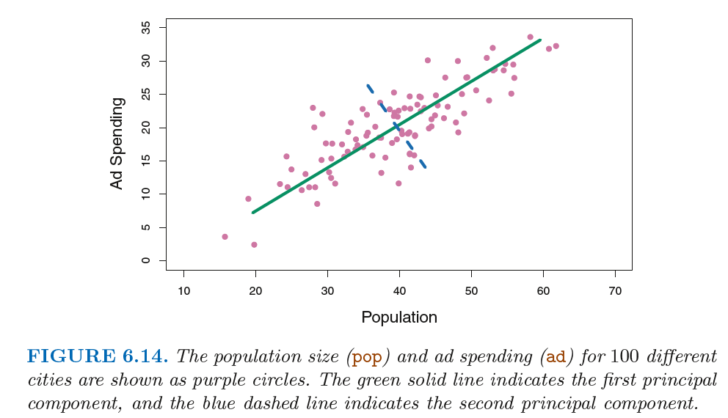

**First Principal Component: (selected features should have linear relationship + high variance)**

The **first principal component** direction of the data is that along which the observations vary the most.

Here φ11 = 0.839 and φ21 = 0.544 are the principal component loadings, which define the direction referred to above. indicates the mean of all pop values in this data set, and indicates the mean of all advertising spending.

The idea is that out of every possible linear combination of pop and ad such that 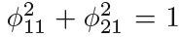, this particular linear combination yields the highest variance: i.e. this is the linear combination for whichis maximized.

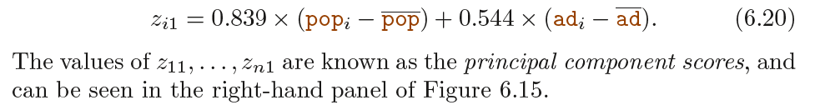

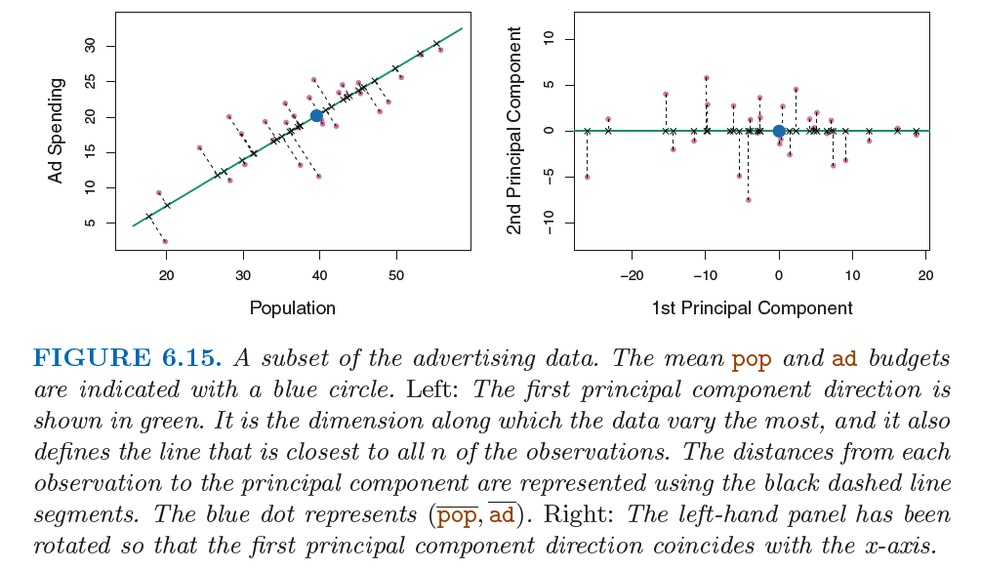

the point in the bottom-left corner of the left-hand panel of Figure 6.15 has a large negative principal component score, zi1 = −26.1, while the point in the top-right corner has a large positive score, zi1 = 18.7.

**Second Principal component: (selected features should be uncorrelated with first Principal component + linear combination + high variance)**

The second principal component Z2 is a linear combination of the variables that is uncorrelated with Z1, and has largest variance subject to this constraint. The second principal component direction is illustrated as a dashed blue line in Figure 6.14. It turns out that the zero correlation condition of Z1 with Z2 is equivalent to the condition that the direction must be perpendicular, or orthogonal, to the first principal component direction.

The principal components were calculated after first standardizing both pop and ad, a common approach.

For 2 dimentional data, at max, we can construct two principal components. For higher dimensions we can construct more. They would successively maximize variance, subject to the constraint of being uncorrelated with the preceding components.

Once we have computed the principal components, we can plot them against each other in order to produce low-dimensional views of the data.

For instance, the first two principal components of a data set span the plane that is closest to the n observations, in terms of average squared Euclidean distance. The first three principal components of a data set span the three-dimensional hyperplane that is closest to the n observations, and so forth.

**Proportion of variance explained: (PVE)**

We can now ask a natural question: how much of the information in a given data set is lost by projecting the observations onto the first few principal components?

More generally, we are interested in knowing the proportion of variance explained (PVE) by each

principal component.

The PVE of each principal component is a positive quantity. In order to compute the cumulative PVE of the first M principal components, we can simply sum over each of the first M PVEs.

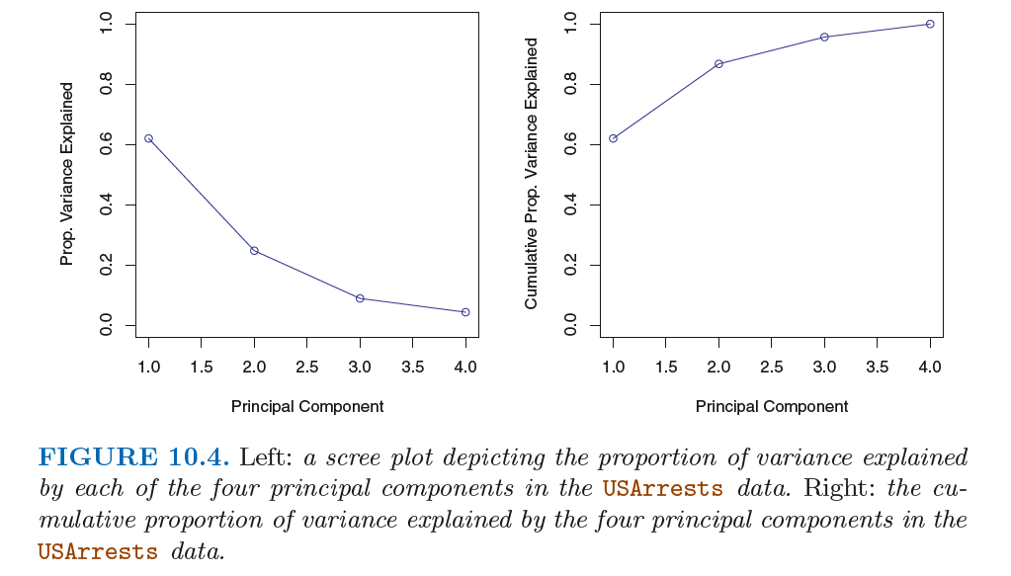

**How many Pricipal components to use?**

No single answer.

In general, a n × p data matrix X has min(n − 1, p) distinct principal components. We choose the smallest number of principal components that are required in order to explain a sizable amount

of the variation in the data.

Use the scree plot between principal component count and prop. variance explained in fig 10.4, look for elbow. After 2, there is an elbow.

**Example for PCA:**

head(USArrests)

str(USArrests)

states <- row.names(USArrests)

states

names(USArrests)

[1] "Murder" "Assault" "UrbanPop" "Rape"

#examining the mean columnwise.

apply(USArrests,2,mean)

Murder Assault UrbanPop Rape

7.788 170.760 65.540 21.232

#checking variance

apply(USArrests,2,var)

Murder Assault UrbanPop Rape

18.97047 6945.16571 209.51878 87.72916

##Applying principle component analysis##

# by default prcomp, standardizes the variables to have mean zero, by giving scale=TRUE, sd will be made 1

pr.out <- prcomp(USArrests,scale=TRUE)

names(pr.out)

[1] "sdev" "rotation" "center" "scale" "x"

dim(pr.out$x)

[1] 50 4

biplot(pr.out,scale=0)

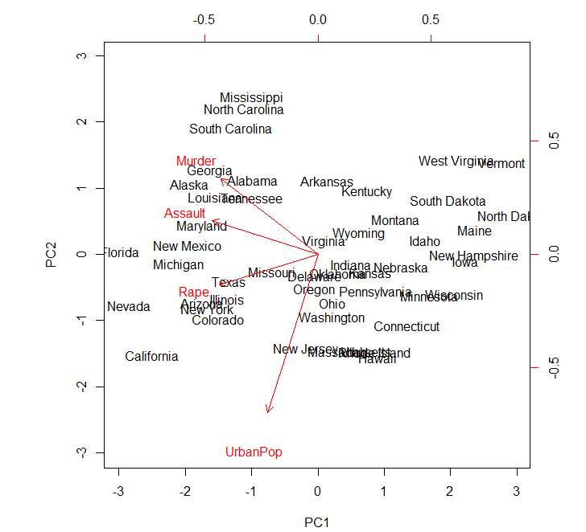

# to change the direction

pr.out$rotation <- -pr.out$rotation

pr.out$x <- -pr.out$x

biplot(pr.out,scale=0)

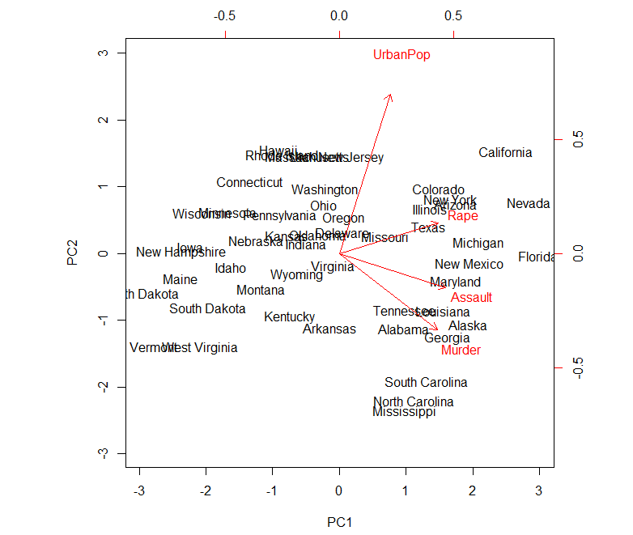

# More loading weight is placed by PC1 on 3 features Rape, Assault and Murder.

# More loading weight is placed by PC2 on Urbanpop

##PVE - Proportion of variance explained

#var/sum(var)

pr.var <- pr.out$sdev^2

pve <- pr.var/sum(pr.var)

pve

[1] 0.62006039 0.24744129 0.08914080 0.04335752

##Plotting PVE and cumulative PVE##

plot(pve,xlab="principle components",ylab="prop. of variance explained", ylim = c(0,1),type="b")

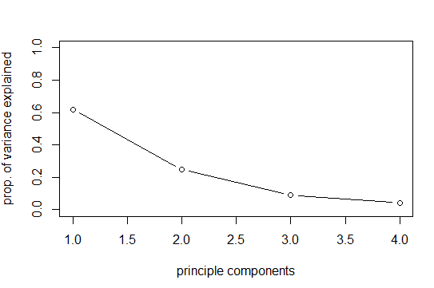

plot(cumsum(pve),xlab="principle components",ylab="cumulative sum of prop. of variance explained", ylim = c(0,1),type="b")

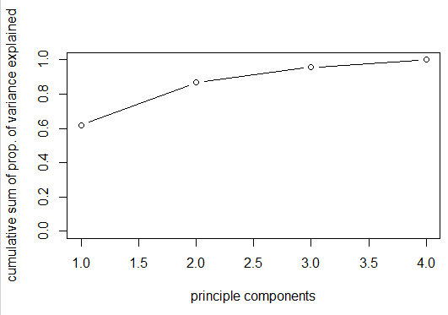

**PCA for multicollinearity:**

**Note:** Multicollinearity can be resolved by combining the highly correlated variables through principal component analysis, or omitting a variable from the analysis.

The simplest and most obvious means of identifying collinearity is an examination of the correlation matrix for the independent variables. The presence of high correlations (generally .90 and higher) is the first indication of substantial collinearity.

Multicollinearity is analyzed through tolerance and variance inflation factor (VIF). As a rule of thumb, if the VIF of a variable exceeds 10, that variable is said to be highly collinear and will pose a problem to regression analysis.

A direct measure of multicollinearity is tolerance, which is defined as the amount of variability of the selected independent variable not explained by the other independent variables.

Tolerance is calculated as 1 - R2*. For example, if the other independent variables explain 25 percent of independent variable X1 (R2* = .25), then the tolerance value of X1 is .75 (1.0 - .25 = .75).

Where R2 is the Coefficient of Determination.

A second measure of multicollinearity is the variance inflation factor (VIF), which is calculated simply as the inverse of the tolerance value. In the preceding example with a tolerance of .75, the VIF would be 1.33 (1.0 ÷ .75 = 1.33).

VIF = 1/1-R^2

**Good Ref link:** <https://beckmw.wordpress.com/2013/02/05/collinearity-and-stepwise-vif-selection/>

**Note**: The take home message is that true relationships among variables will be masked if explanatory variables are collinear. This creates problems in model creation which lead to complications in model inference. Taking the extra time to evaluate collinearity is a critical first step to creating more robust ecological models.

rand.vars => contains list of independent variables

keep.dat<-vif_func(in_frame=rand.vars,thresh=5,trace=F)

form.in<-paste('y ~',paste(keep.dat,collapse='+'))

mod2<-lm(form.in,data=lm.dat)

summary(mod2)

**Difference between PCA and PLS:**

<https://www.quora.com/What-is-the-difference-between-PLS-and-PCA>

When you reduce features using PCA, the idea is to maximize the variance of the features itself, such as the loss of information is greatly reduced. However, the PCA only looks at those features as high-dimensional points and do not take into account the classification label associated to them.

On the other side, Partial Least Squares, use the annotated label to maximize inter-class variance. That means we take into account the classes and try to reduce the dimension while maximizing the separation of classes, which is ideal in a classification scenario.

**PLS:**

**Good link:** <https://stats.idre.ucla.edu/wp-content/uploads/2016/02/pls.pdf>

<https://www.r-project.org/doc/Rnews/Rnews_2006-3.pdf>

<https://www.research.manchester.ac.uk/portal/files/60829807/FULL_TEXT.PDF>

Ref:

<https://www.youtube.com/watch?v=Qt3Vv5KsnpA&index=5&list=PLzOz0tl6F3-BEcoYz3C8K5_NrOqpryzYv>

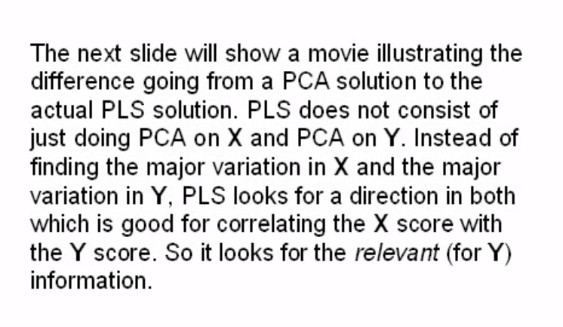

**PLS1 is if Y is univariate, PLS2 is if Y is multivariate.**

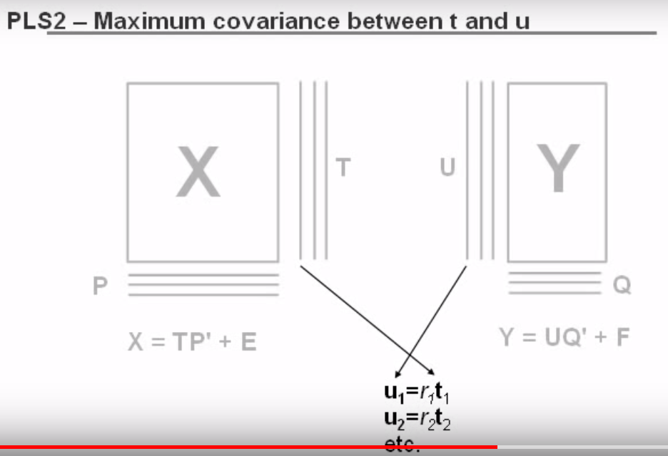

T is score of X and P’ is loadings of X..similarly U is score of Y and Q’ is loadings of Y.

The first score is chosen in such a way that first y score is highly correlated with first x score..etc..

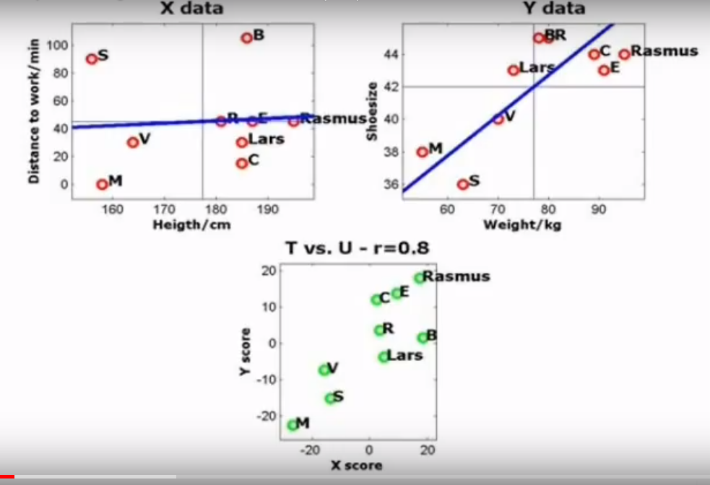

Blue line indicates loadings and scores are indicated in green dots.. X loadings will be adjusted in such a way that the correlation between the T and U scores increases.

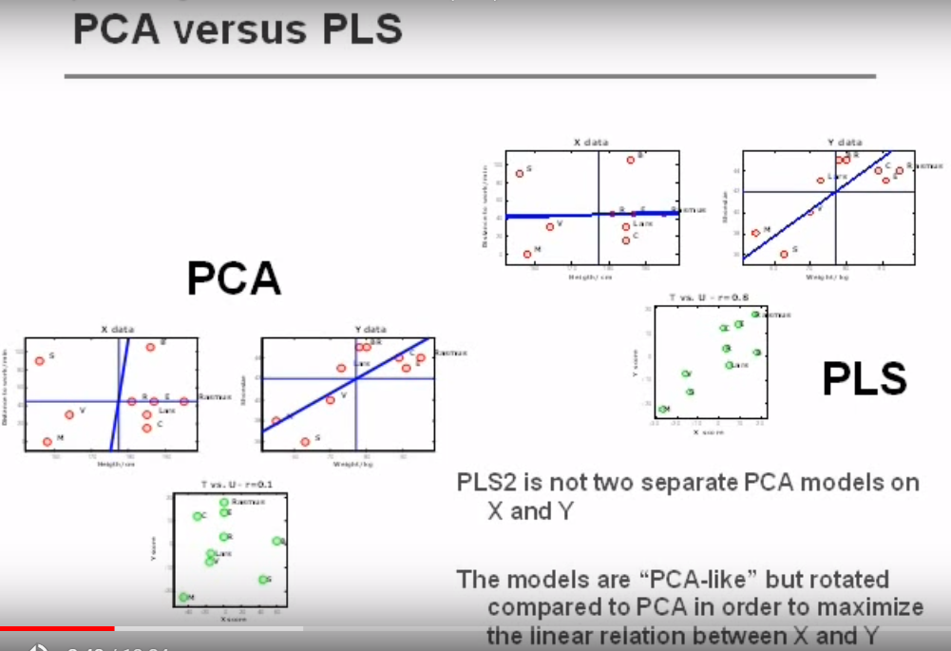

**Model accuracy estimation:**

[**https://machinelearningmastery.com/how-to-estimate-model-accuracy-in-r-using-the-caret-package/**](https://machinelearningmastery.com/how-to-estimate-model-accuracy-in-r-using-the-caret-package/)

**Linear Discriminant Analysis:**

<https://www.r-bloggers.com/linear-discriminant-analysis-in-r-an-introduction/>

<https://www.youtube.com/watch?v=azXCzI57Yfc>

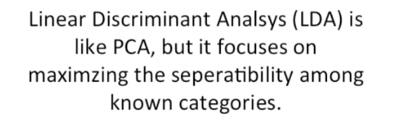

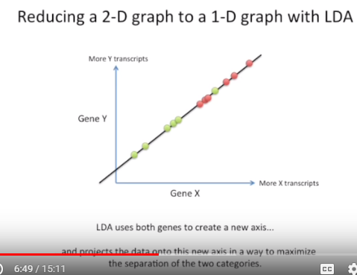

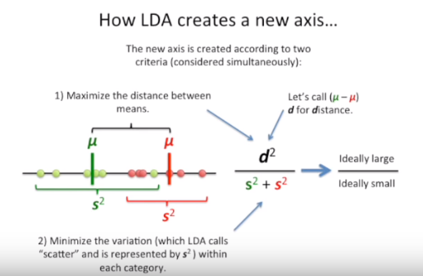

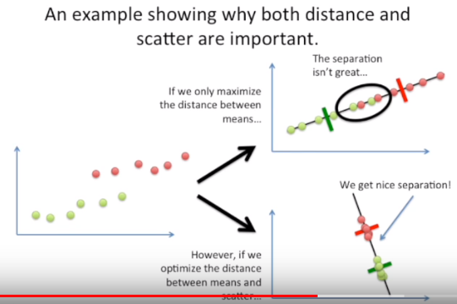

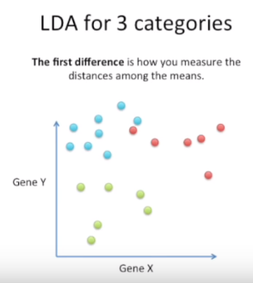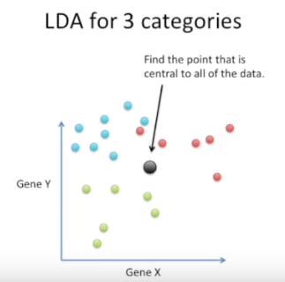

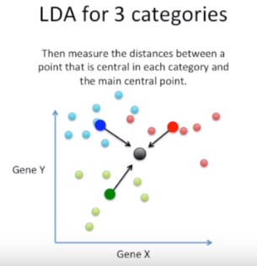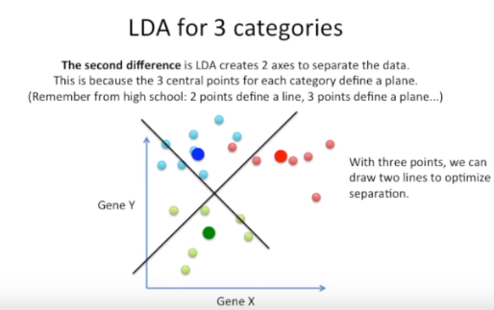

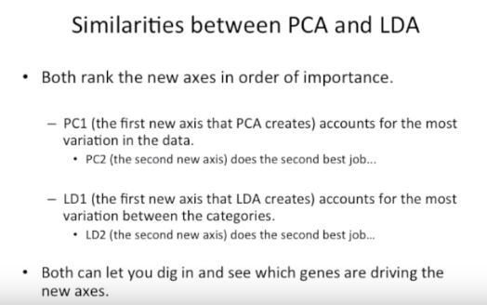

In PCA, we look at loading scores

In LDA, we can see which variables correlates

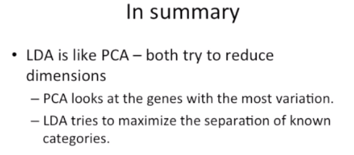

Why LDA better than logistic?

1. If the classes are well-separates, logistic model is surprisingly unstable.
2. If n is small, LDA is more stable than logistic.
3. LDA is more popular when there are more than 2 response classes.

**Polynomial regression:**

Polynomial regression extends the linear model by adding extra predictors, obtained by raising each of the original predictors to a power.

For example, a cubic regression uses three variables, X, X2, and X3, as predictors. This approach provides a simple way to provide a nonlinear fit to data.

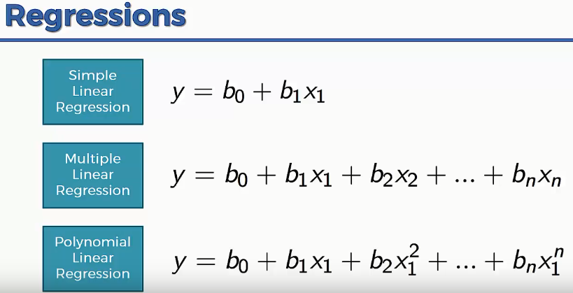

When to go polynomial regression?

<https://www.theanalysisfactor.com/regression-modelshow-do-you-know-you-need-a-polynomial/>

A quadratic term creates a curve with one “hump”–  a U or inverted U shape.  The curve does not need to contain both sides of the U.  In can contain just part of it.

A cubic has two humps–one facing upward and the other down.  The curve goes down, back up, then back down again (or vice-versa).

**Neural Network:**

Always normalize the data for the algorithm to converge and get right results. Especially when the range of min and max values of the columns differ much.

**Package:** neuralnet

Dot(.) notation cannot be used on Neural network in formula.

compute() is used for prediction instead of predict() as in other regression models.

**Probability and statistics:**

**Meta-phrasing:**

Refers to literal translation of a real world problem into mathematical representation.

Set theory and venn diagrams are used for mathematical representation of real world problems.

**Combination formula:**

n is the toal number of options, r is number of options we are interested in.

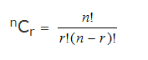

Choose command is used in r to compute combination.

> choose(4,2) # here n= 4, r =2

[1] 6

> choose (6,3) # here n =6, r=3

[1] 20

If repetition is allowed, in a problem where the urn is having 3 red balls and 4 green balls and we ned to select 2 red balls and 2 green balls with replacement.

3C1 * 3C1 * 4C1 * 4C1 = 3 *3 * 4 * 4 = 144.

Since the problem is having green and red ball selection 🡺 we are multiplying. If it is red or green, then, we add the result combinations.

**Permutation:**

Permutation deals with order/sequence. Note: repetition is not allowed

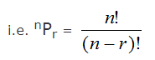

n – total number of options, r -> number of options we are interested in.

If repetition is allowed, 3^2 🡺 #choices^#selections

1. There are four bus routes from A to B and three bus routes between B and C. A man can travel a round trip in number of ways from A to C via B.If he doesn't want to use a bus route more than once, in how many ways he can make a round trip ?

**Answer:**

Basic multiplication rule applies here

A to B : 4 ways

B to C : 3 ways

C to B : 2 ways (1 way is already used while travelling from B to C)

B to A : 3 ways (1 way is already used while travelling from A to B)

Total number of ways = 4*3*2*3 = 72 ways

1. Determine the total possible ways in which a team of 11 players can be selected from 20 players. 2 players out of 20 have to be included always and 3 players out of 20 have to be excluded always?

**Answer:**

2 players have to be included always and 3 will be excluded always so, remaining, 9 players to be found from 15 players, so 15C9 = 5005

1. How many 5-digit numbers can be formed using (0-9)?

**Answer:**

(1) : Without Repetition of digits, 27,216 numbers;

(2) : With Repetition, 90,000 numbers.

**Explanation:**

There are 2 Possibilities to be considered :-

**Case (1) : Digits not repeated :-**

Usually, we do not write the Left-most (the 1st) digit 0, so, this digit can be any 1 out of 1,2,...,9.

Thus, the 1st digit can be selected in 9 ways.

Coming to the selection of the 2nd digit, keeping in mind that we can not choose the digit which we have already chosen while selecting the 1st digit, we have to select it from 10−1=9 digits, & this can be done in 9 ways.

Now, for the 3rd, we have 10−2=8 choices.

For the 4th,7 and, for the last 5th,6 ways are there.

Finally, using the Fundamental Principle of Counting, we can form

9×9×8×7×6=27,216 five-digit nos. without repeating any digit.

**Case (2): Digits repeated :-**

In this case, the 1st digit can be selected in 9 ways as in the Case (1).

For the 2nd place, we have 10 choices from 0,1,2,...,9. So, this can be done in 10ways.

Now repetition is allowed. So, for the selection of digits for the places from 3rd to the 5th, we again have 10 choices to choose from.

Accordingly, if repetition of digits is permitted, the five-digit numbers can be formed in:  
9⋅10⋅10⋅10⋅10=90000 ways.

1. Identify the count of all possible 9 digit numbers that can be made using the digits 0 to 9 without repetition.

**Answer:**

9(9!)

1. Scenario: A box contains 3 red balls, 2 blue balls and 1 green ball. One ball is picked randomly. What is the probability that it will be a blue ball .

**Solution:**

Total possible outcomes = Total number of balls = 3+2+1=6

Total ways a blue ball can be drawn = 2C1 = 2

 Probability of drawing a blue ball = 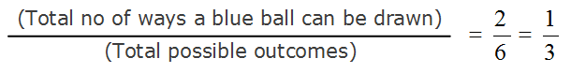

1. Two coins are tossed simultaneously 1000 times, and we get two heads 305 times and one head 275 times.

Find the probability of getting at least one tail.

**Answer: 0.695**

**Bayes theorem (conditional probability):**

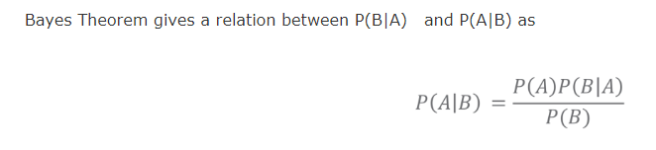

1. A man is known to speak truth 3 out of 4 times. He throws a die and reports that it is a six. Find the probability that it is actually a six.

**Answer:**

E = the man reports six

P(S1)= Probability that six actually occurs = 1616

P(S2)= Probability that six doesn't occur= 5656

P(E|S1)= Probability that the man reports six when six has actually occurred = 3434

P(E|S2)= Probability that the man reports six when six has not occurred = 1−34=141−34=14

Therefore, by Bayes' Theorem,  
P(S1|E)=(1/6⋅3/4)/[(1/6⋅3/4)+(5/6⋅1/4)]=3/8

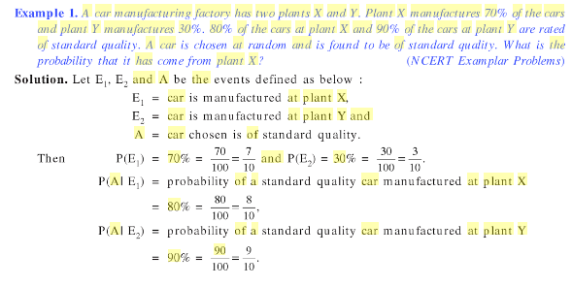

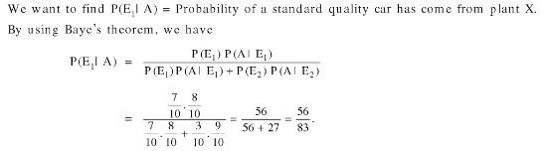

1. A boy has 33 library tickets and 88 books of his interest in the library of these 8,8, he does not want to borrow maths part 22 unless maths part 11 is borrowed? In how many ways can he choose the three books to be borrowed?

**Answer:**

Case 1: 3 books without including maths part 1 and part 2  
6C3=206C3=20 ways  
  
Case 2: (maths part 1) and (two books)  
7C2=217C2=21 ways  
  
Required number of ways  
=20+21=41

1. How many number of signals that can be sent by 6 flags of different colors taking one or more at a time?

**Answer:**

There are 5 flags.

Total number of signals made using 5 different coloured flags = 5p1+5p2+5p3+5p4+5p5 = 325

1. One card is drawn from a well-shuffled deck of 52 cards. Calculate the probability that the card will be an ace.

**Answer:**

P(A) = number of ace cards/Total number of cards

= 4/52

**Statistics:**

**2 types:**

1. Descriptive statistics - > can be measured from the sample
2. Inferential statistics -> abstract and it just describes the conclusion or summarization of the feel. Cannot be measured.

**Descriptive statistics**

some of the measure used to describe the data are:

1. Measure of central tendency
2. Measure of dispersion
3. Measure of shape

Sample: section of the data, sample mean is represented as x bar.

Population: all the data, population mean is represed as mu.

**Weighted mean:**

Weighted mean is used when some values in the data set contribute more than others.

Weighted mean is computed using the following formula:

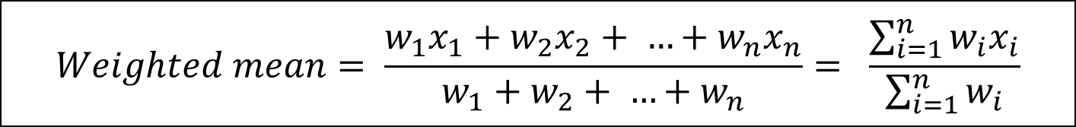

The weighted mean can be computed using the command weighted.mean(x,w) in R as shown below:

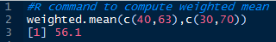

1. A class of 25 students took a science test. 15 students had an average arithmetic mean score of 80. Remaining students had an average score of 60. What is the average score of the whole class?

**Answer:**

15*80 + 10*60/25 = 72

Or using R,

> weighted.mean(c(80,60),c(15,10))

[1] 72

**Geometric Mean:**

In a test, the laboratory observes the growth of germs in water present in lakes/ponds spread across the city in order to check on the possibility of water borne diseases.

The laboratory take samples of water from each such water body and observes the growth of bacteria and other microbes.

The laboratory observes that bacteria grew by 20% in the first hour, 20% in the second and 15% in the third hour.

What is the average growth rate of bacteria in this sample?

If the sample initially contained 1000 bacteria what is the estimated number after 3 hours?

Geometric mean is used while finding the average of numbers that represent growth rate.

It is used in cases where a set of numbers need to be multiplied to get the required result.

Here, the number of bacteria after 3 hours is computed as *1000 x 1.2 x 1.2 x 1.15 = 1656*.

Geometric mean is the nth root of the product of n numbers, as shown below:

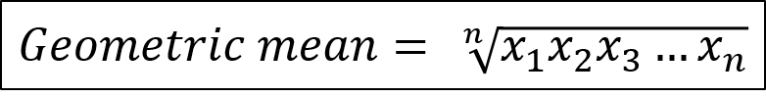

The geometric mean of the example cited earlier is:

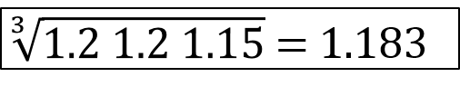

Using the geometric mean, the number of bacteria after 3 hours can be computed as *1000 x 1.183 x 1.183 x 1.183 = 1655.59 ~ 1656.*

Geometric mean represents a single value that is equivalent to the all the values in the data set.

Geometric mean can be used only for positive values. In this example, if the bacteria had decreased by 10 percent in the third hour, then the geometric mean would be (1.2 x 1.2 x 0.9)1/3.

Geometric mean works best when the values are close to each other in the data set.

The geometric mean can be computed using the command **geometric.mean(x)** of **psych**package in R as shown below:

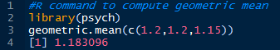

**Harmonic mean:**

The heart condition of individuals are diagnosed by recording their heart rates at different points of time.

Individuals are required to perform various tasks while their heart rate is being recorded. Here is the observation of an individual’s heart rate during the test:

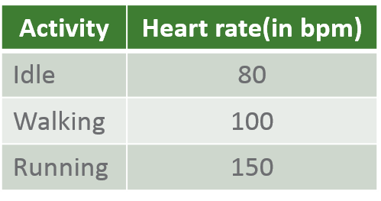

What is average heart rate of this individual?

Harmonic mean is a better estimate of the average of data in situations where the data represents rates/ratios such as speed (km per hr.), heart rate(beats per min.), frequency etc.

Harmonic mean is the reciprocal of the arithmetic mean of the reciprocals, as shown below:

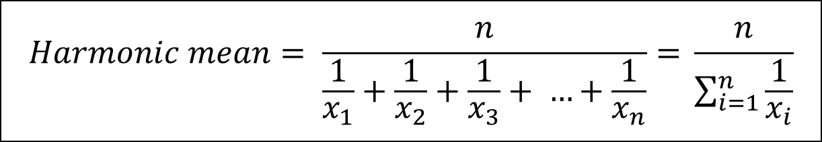

The average heart rate of the individual using the data observed earlier is approximately *103 bpm*.

The harmonic mean can be computed using the command **harmonic.mean(x)** of **psych**package in R as shown below:

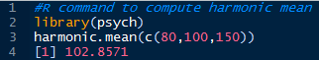

 Harmonic mean cannot be calculated for data having zero or negative values.

**Measure of dispersion:**

Consider two different communities in the city which have 5 doctors each, given below is the number of patients each doctor attends to in a day:

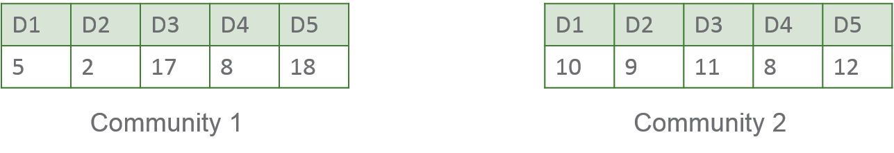

The average number of patients that a doctor attends to in both communities is the same (10), however all doctors in community 2 seem to be equally busy as opposed to community 1 where a few are very busy and others are not.

This indicates that to completely describe the nature of a data set, measures of central tendency may be inadequate.

Dispersion represents the variability in the data.

Measures of dispersion are representative of how squeezed or stretched the data is in comparison with the measures of central tendency.

A measure of dispersion is a non-negative real number which grows as the diversity of data grows.

Commonly used measures of dispersion are **Range**, **Variance**, **Standard deviation** and **inter quartile range**.

**Range:**

Range is the simplest measure of dispersion that aims at providing an idea of how much the data varies in the data set.

Range is expressed as



In the example cited earlier(shown below for reference), range of number of patients in community 1 is *(18-2)*,  whereas that of community 2 is *(12-8)*.



Range indicates the spread of the data, in this case it indicates that data of community 1 is more dispersed than that of community 2.

The **range(x)** commandin R gives the minimum and maximum values of a data set as shown below:

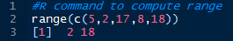

**Variance:**

Range may be inadequate when looking at larger data sets which contain extreme values (as minimum and maximum)

Variance is a better indicator of dispersion – it describes the deviation of data from each other and from the mean.

Variance for a population of size N is calculated as shown below



In the data set used earlier (shown below for reference)



The sample variance of community 1 is **51.5** and that of community 2 is **2.5.**

We observe that variance is a much better indicator of dispersion in comparison with range.

Note: Variance is expressed in square units. In the example discussed above, the variance is in *(no. of patients)2*

The variance can be computed using the command **var(x)** in R as shown below:

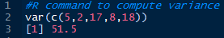

**Standard Deviation:**

Standard deviation represents the actual variation of the data from the mean and is represented in the same unit as that of data.

Standard deviation is the square root of the variance and is computed as shown below:

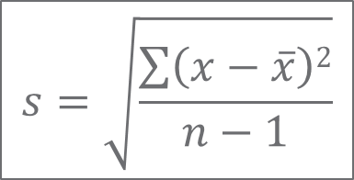

We can use either the standard deviation or the variance to report the dispersion of data.

Population standard deviation is represented by **σ** and sample standard deviation is represented by **s**.

In the data set used earlier (shown below for reference)



Standard deviation of community 1 is *7.176* and that of community 2 is *1.581*.

The standard deviation can be computed using the command **sd(x)** in R as shown below:

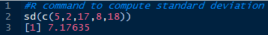

**Chebyshev’s inequality:**

Chebyshev's inequality relates mean and standard deviation. It is bound on the probability of finding a value.

The probability of finding a value closer to the mean is high and the further the value disperses from the mean, the lower the probability of finding it in the data set.

This inequality is expressed as: 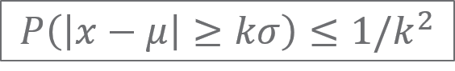

which says that " *If the value is k standard deviations away from the mean, then the probability of finding it is lesser than 1/k^2*"

**z-score:**

Comparison of data from different data sets is done by observing how the data compares against the mean in the data set that it originates from.

This comparison can be performed using z-score, which indicates the distance of the data from the mean in terms of standard deviations.

Example: A z-score of 2 indicates that the data is greater than the mean by 2 standard deviations, while a score of -1.3 indicates that the data is lesser than the mean by 1.3 standard deviations

z-score of a specific value(x) is computed using the formula:

z-score of Doctor 1 is (78-72) / 4 = 1.5, and

z-score of Doctor 2 is  (76-68) / 3 = 2.33.

This indicates that Doctor 2 is a more suitable candidate in this scenario.

**Measure of shape:**

<https://keydifferences.com/differences-between-skewness-and-kurtosis.html>

**Skewness:**

Skewness is the measure of lack of symmetry of the data in comparison with a symmetric distribution. In a symmetrically distributed data set, the mean and the median coincide.

If there is an unusually large value in the data set, the mean becomes greater than the median, this indicates a **right-skewed** data. On the other hand, if there are unusually small values, the mean becomes lesser than the median, this indicates **left-skewed** data.times

Skewness of a data set is derived using the following formula:



Skewness helps us understand if mean is the right measure of central tendency to use while making decision about the data. In the case of community 1 and 2, the mean and median are pretty close which indicates that mean is an acceptable measure to use here.

The skewness can be computed using the command **skewness(x)** of **moments**package in R as shown below:

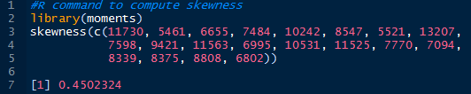

**Kurtosis:**

The nature of data to peak or flatten about the mean can be described using kurtosis.

Kurtosis helps us identify whether the data spread around the mean is high or not.

A higher value of kurtosis indicates that data is largely centered around the mean while a lower value of kurtosis indicates that data is not centered around the mean.

Kurtosis of a given data set can be calculated using the following formula:

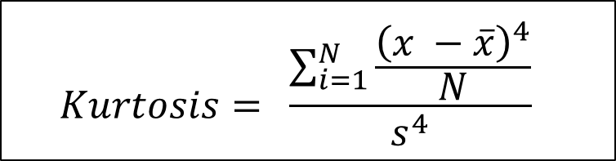

The kurtosis for the data set shown earlier is 7.844213, which indicates a high peak.

A value of kurtosis above 3 indicates a peak, while that below 3 indicates flatness.

The kurtosis can be computed using the command **kurtosis(x)** of **moments**pakage in R as shown below:

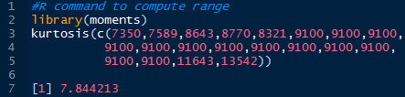

<https://www.teachoo.com/2082/573/Example-34---A-college-awarded-38-medals-in-football--15-basketball/category/Examples/>

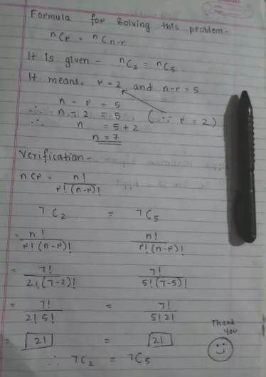

<http://www.studyn.us/blog/sat-probability-questions/>

**Opinion Mining:**

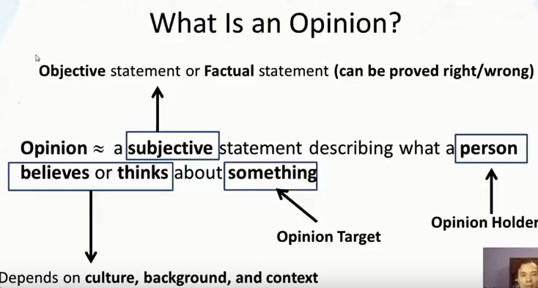

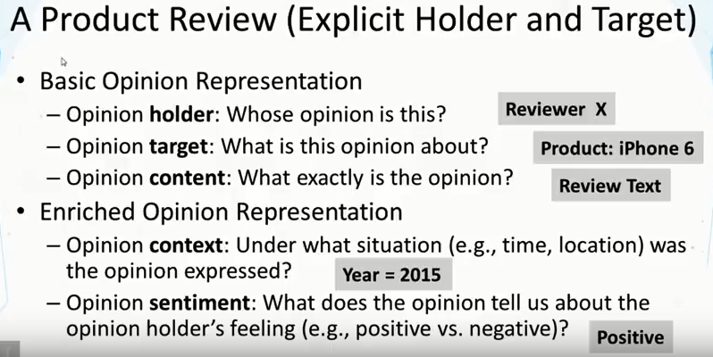

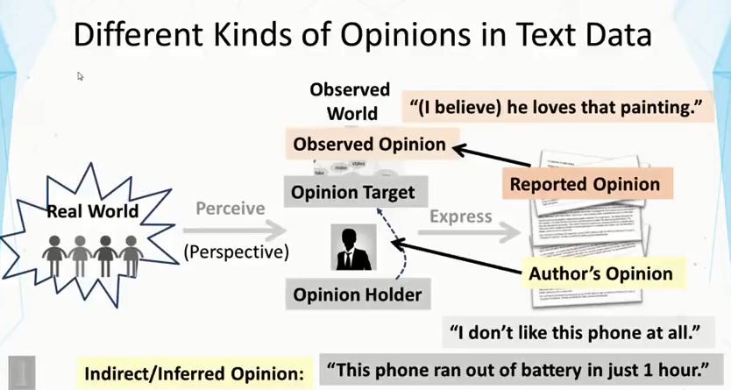

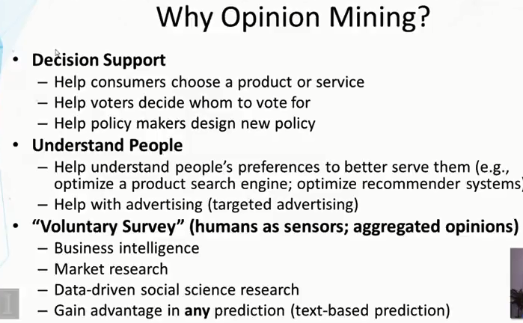

**Data Cleaning operations:**

1. Check for NA values

Let's see if we have any NA values:

In [4]: any(is.na(df))

Out[4]: FALSE

1. **Categorical Features:**
   1. let's make sure that categorical variables have a factor set to them.

str(df)

1. **Finding correlations and corrplots:**

# Grab only numeric columns

num.cols <- sapply(df, is.numeric)

# Filter to numeric columns for correlation

cor.data <- cor(df[,num.cols])

cor.data

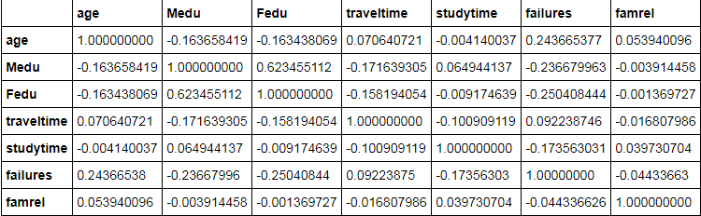

#install.packages('corrgram',repos = 'http://cran.us.r-project.org')

#install.packages('corrplot',repos = 'http://cran.us.r-project.org')

library(corrplot)

library(corrgram)

corrplot(cor.data,method='color')

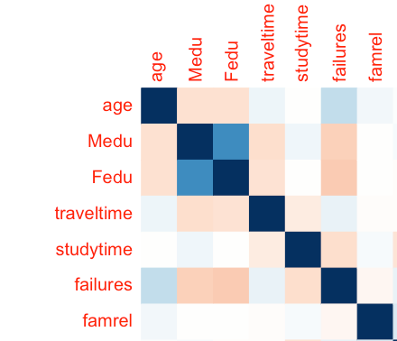

corrgram(df,order=**TRUE**, lower.panel=panel.shade,

upper.panel=panel.pie, text.panel=panel.txt)

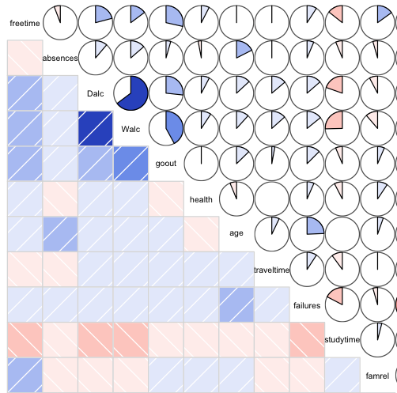

1. Imputing missing data with mean of the group.

To execute a .r file in console use source command:

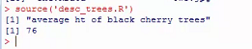

**> # Taking care of missing data**

> dataset$Age <- ifelse(is.na(dataset$Age), mean(dataset$Age , na.rm = TRUE), dataset$Age)

**(or)**

> dataset$Age <- ifelse(is.na(dataset$Age),

+ ave(dataset$Age, FUN= function(x) {

+ mean(x,na.rm=TRUE)}),

+ dataset$Age)

(or)

library(MLR)

imp1 <- impute(data = train,target = "target",classes = list(integer=imputeMedian(), factor=imputeMode()))

imp2 <- impute(data = test,target = "target",classes = list(integer=imputeMedian(), factor=imputeMode()))

train <- imp1$data

test <- imp2$data

1. Encoding Categorical data:

> dataset$Country <- factor(dataset$Country ,

+ levels = c('France','Spain','Germany'),

+ labels = c(1,2,3))

1. Feature scaling (Not required for Linear regression models ) Feature scaling is not required for the models which are not based on Euclidean distances.

>training_set[,2:3] = scale(training_set[,2:3])

>test_set[,2:3]= scale(test_set[,2:3])

1. To check the distribution of classes and their percentage:

#check table  
table(hacide.train$cls)  
  0     1   
980    20

#check classes distribution  
prop.table(table(hacide.train$cls))  
  0      1    
0.98   0.02

(or)

Being a binary classification problem, you are always advised to check if the data is imbalanced or not. We can do it in the following way:

* setDT(train)[,.N/nrow(train),target]
* target     V1
* 1: <=50K   0.7591904
* 2: >50K    0.2408096
* setDT(test)[,.N/nrow(test),target]
* target     V1
* 1: <=50K.  0.7637737
* 2: >50K.   0.2362263

1. In above result, we could see that for test data, target column values are having additional dot(‘.’), To remove that

test[,target := substr(target,start = 1,stop = nchar(target)-1)]

1. To cut down space at the beginning of a column values,

library(stringr)

char_col <- colnames(train)[sapply(train,is.character)]

for(i in char_col)

set(train,j=i,value = str_trim(train[[i]],side = "left"))

1. To delete the columns which are with just one value

fea_unique_values <- sapply(Adjusted_SKU_db, n_distinct)

(fea_del <- names(fea_unique_values[fea_unique_values==1]))

Adjusted_SKU_db %<>% select (-one_of(fea_del))

Types of Recommendation/Recommender Systems:

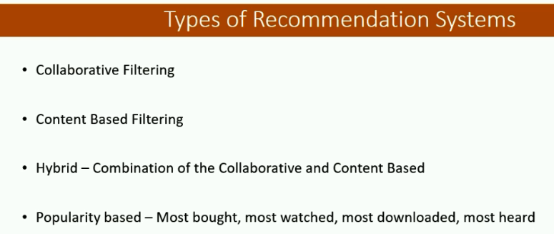

**Collaborative Filtering:**

* What is Collaborative Filtering?
  + Collaborative filtering (CF) is for building personalized recommendations.
  + The algorithm predicts about a users interest based on preferences from several users.
  + Companies like Google use it for maximizing Ad revenue, Amazon uses it for recommending similar items, Facebook uses to recommend the friends you know, Netflix uses it for recommending movies.
  + It uses the User behavior for recommending items.
* Drawbacks:
  + These distances work best when there is no missing values.
  + How to differentiate the rating of 4 by User A with the rating of 4 given by User B?
* Pearson Correlation Coefficient:

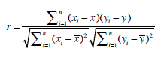

How do I find someone who is similar ?

* + Manhattan Distance

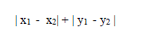

* + Euclidean Distance

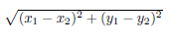

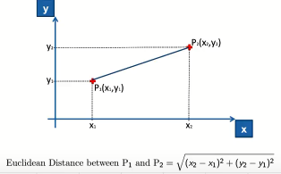

* + Minkowski Distance

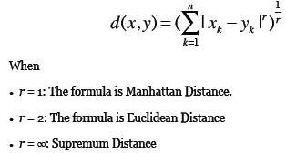

* + Cosine Similarity

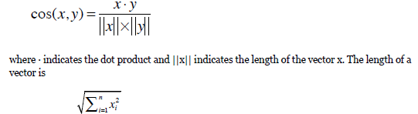

If we care about the direction of the data rather than the magnitude, then using the **cosine distance** is a common approach. It computes the dot product of the two data points divided by the product of their magnitude. Cosine distance, together with the term/document matrix, is commonly used to measure the similarity between documents.

* + K-Nearest Neighbor

In K-nearest neighbor approach to collaborative filtering we use K most similar people to determine recommendations.

* Ratings:
  + Implicit - Obtained by observing the user behavior.
    - Clicking a link to a page
    - Time spent looking at a page
    - Repeated visits to a page
    - Referring a page to another user
  + Explicit – User themselves explicitly rate the items
  + Drawbacks of Explicit Ratings:
    - People are lazy and don’t rate items
    - People may lie or give partial information
    - People don’t update their ratings
* **Collaborative Filtering Types**
  + **User Based**
    - Used for comparing a user with another user to find the closest match.
    - In user-based filtering we find the most similar person to a user and use the ratings of that similar person to make recommendations.
    - Drawbacks of User based filtering
      * Scalability – Computation increases as number of users increases
      * Sparsity –
      * Since average user rates a small fraction of the total products. So, the User based filtering having many users and many products may not find any nearest neighbor.
  + **Item Based**
    - In item-based filtering, find the most similar items much before hand, and combine it with a user's rating of items to generate a recommendation.
    - Adjusted Cosine Similarity – Used for Item based recommendation to remove grade inflation where a user gives higher ratings than expected.

**Collaborative filtering:**

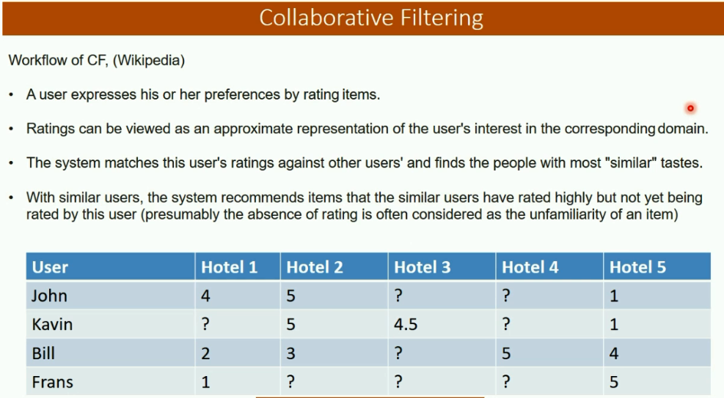

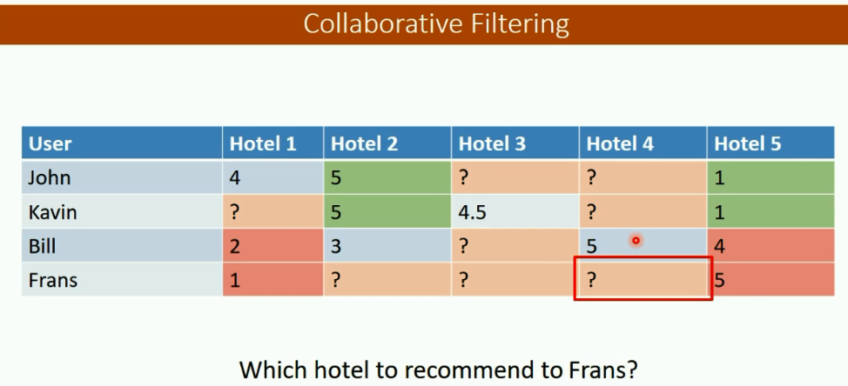

**Content based filtering:**

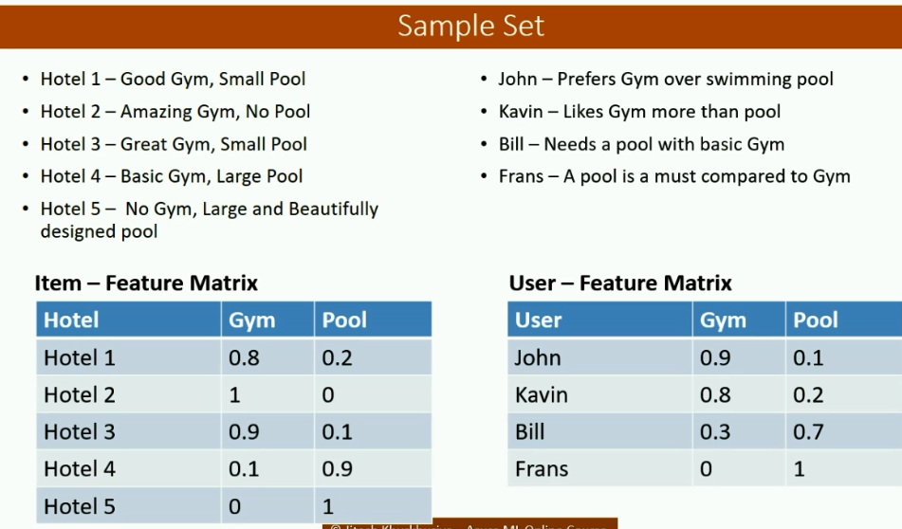

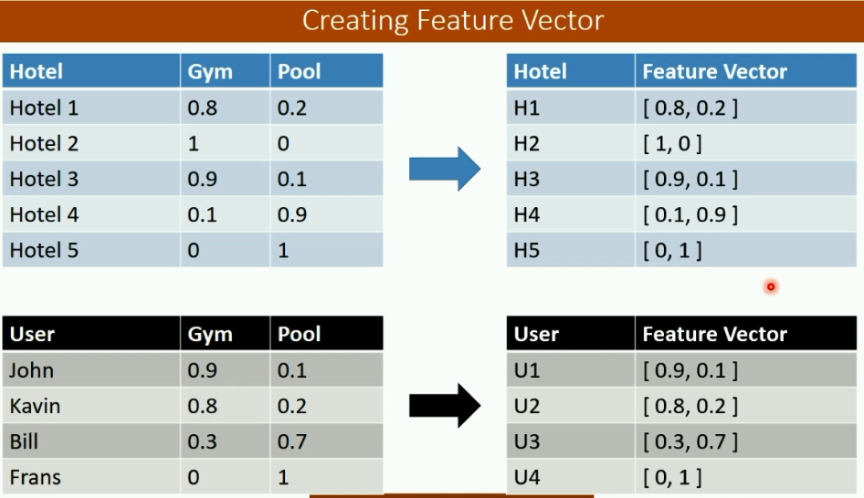

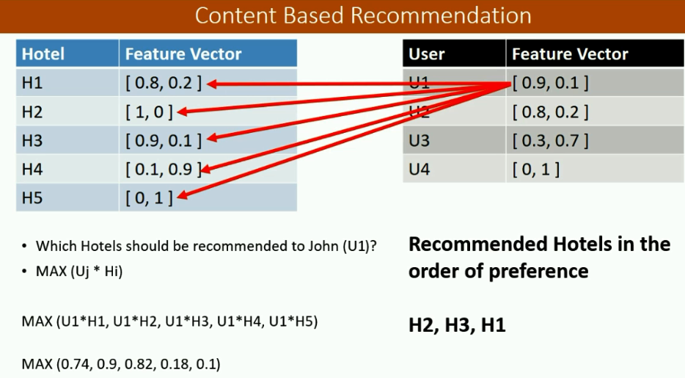

**Recommendation data issues:**

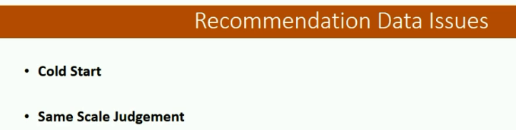

**Cold start:**

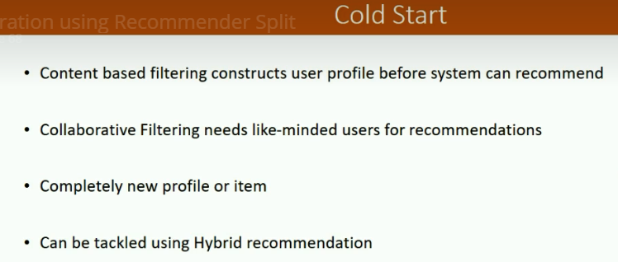

**Same scale judgements:**

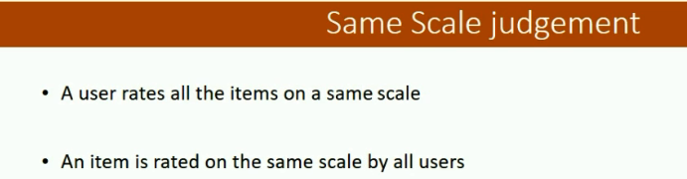

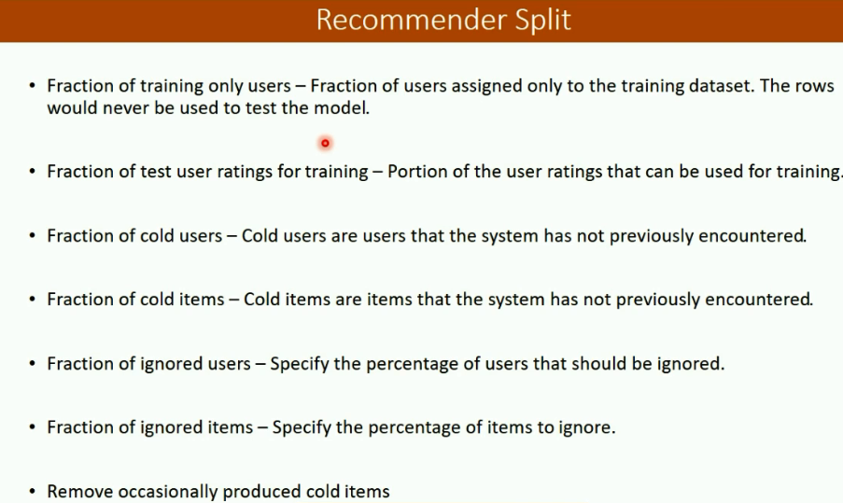

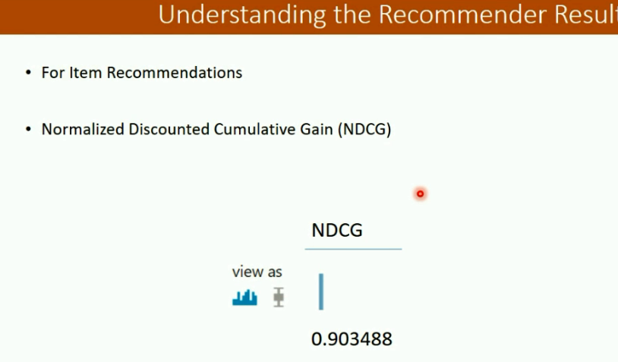

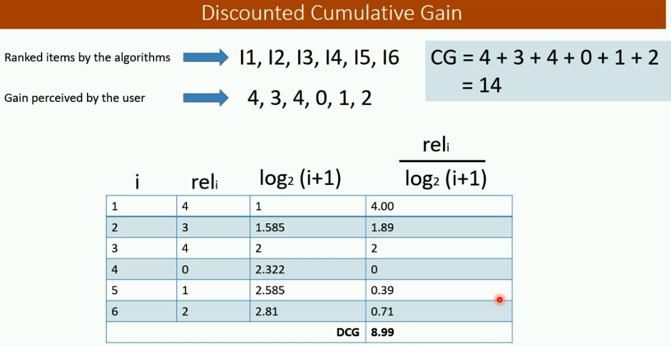

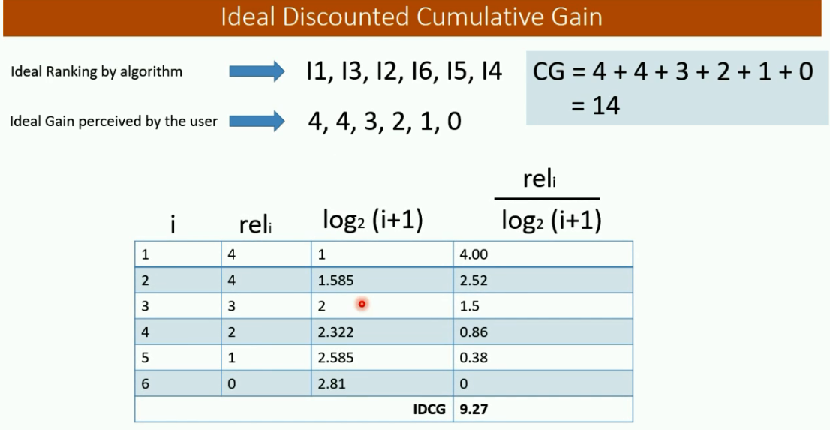

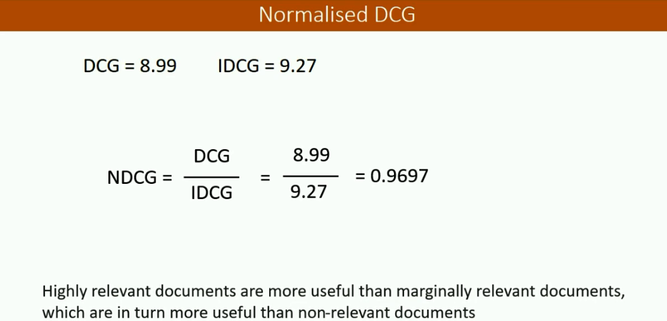

Non standard evaluation

<http://adv-r.had.co.nz/Computing-on-the-language.html>

**Debugging:**

R comes with a set of built-in tools for interactive debugging that can be useful for tracking down the source of problems. These functions are

* browser(): an interactive debugging environment that allows you to step through code one expression at a time
* debug() / debugonce(): a function that initiates the browser within a function
* trace(): this function allows you to temporarily insert pieces of code into other functions to modify their behavior
* recover(): a function for navigating the function call stack after a function has thrown an error
* traceback(): prints out the function call stack after an error occurs; does nothing if there’s no error

**Performance related articles:**

<https://rstudio.github.io/profvis/index.html>

<http://adv-r.had.co.nz/Performance.html>

<http://www.noamross.net/blog/2013/4/25/faster-talk.html>

<https://www.youtube.com/watch?v=-yy_3htRHdU>

1. > traceback() # call stack will be displayed

2. >options (error = recover) # if error occurs it calls the recover which enters into the function to check the state of the function.

3. Rerun the function call, this time we will see the call stack.

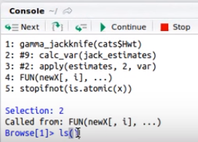

We can check the list of variables at that particular state using ls()

And try to execute the function at that state and we got the error.

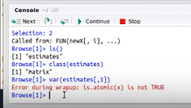

When we tried to see estimates[,1] to identify why var on column is failing, estimates column is a list.

Var function can be applied only on numeric vectors and not on list. So that’s the issue.

* In Browse> prompt, type n and Enter, it will run the next line of code
* Type c and enter, to run the remaining part of code
* Type Q, to quit the browser mode.

**Variance Bias Tradeoff:**

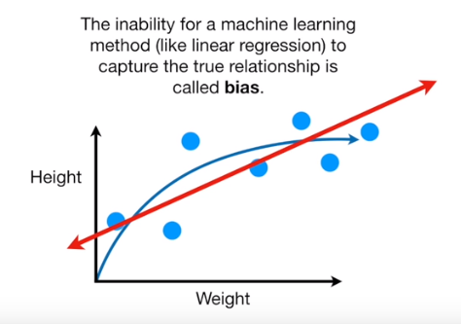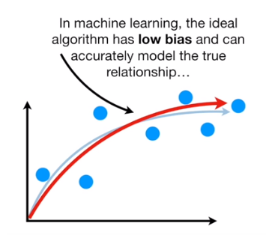

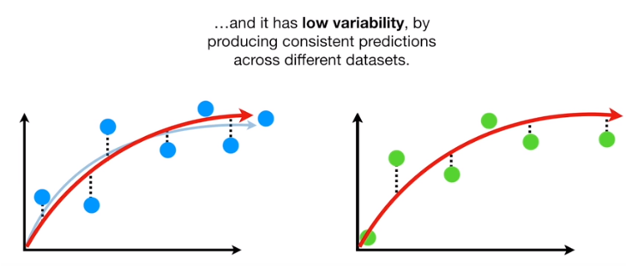

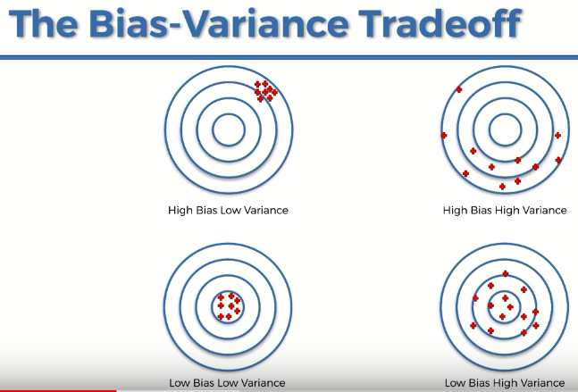

Bias is associated with accuracy. Low bias means high accuracy.

**XGBoost:**

**Advantage:**

1. High performance.
2. Fast execution speed.
3. No need of scaling. We can retain same interpretation.

**Regularization:**

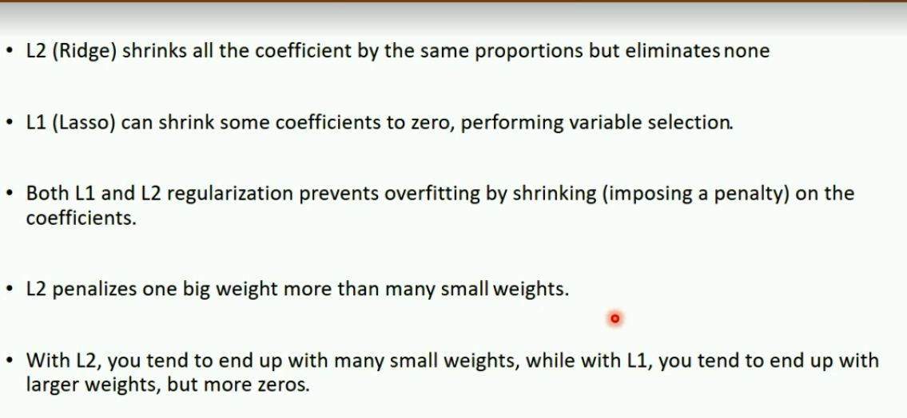

**MICE:**

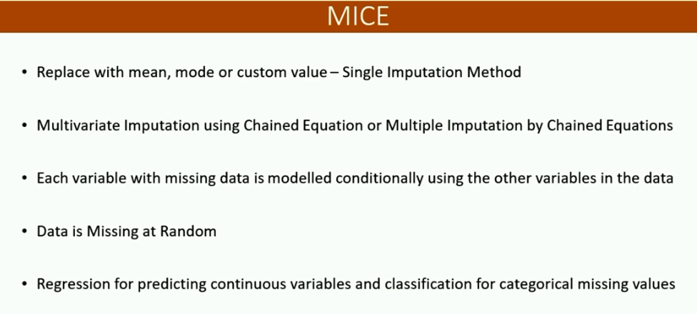

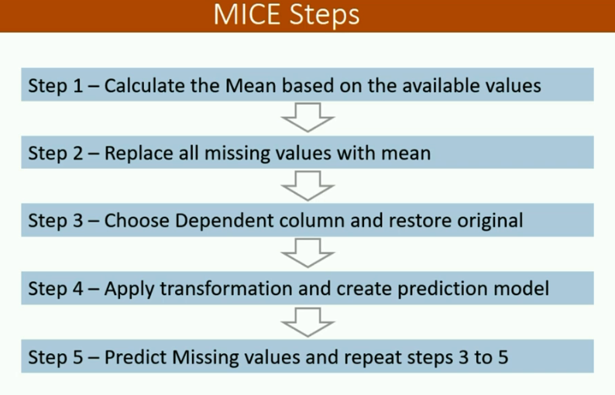

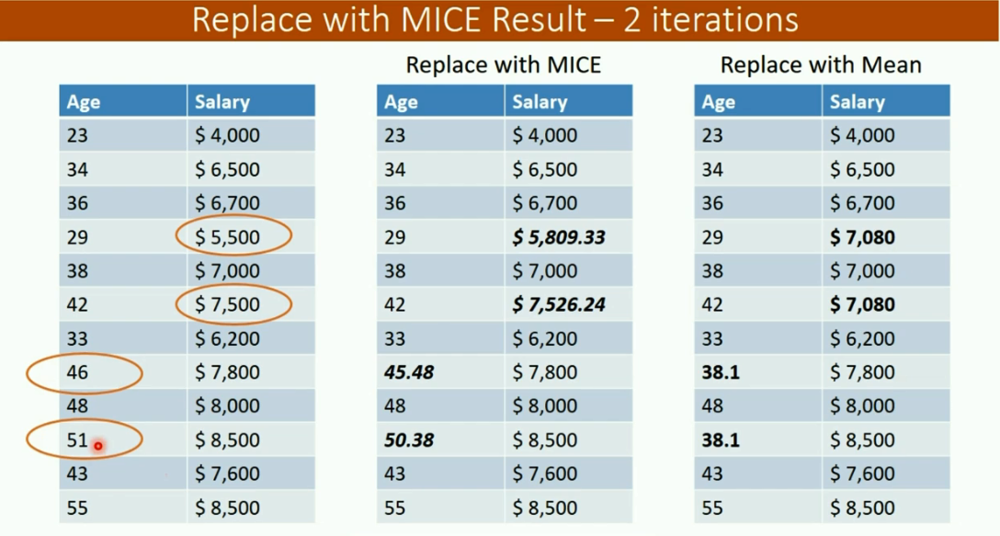

**SMOTE (Synthetic Minority Oversampling Technique):**

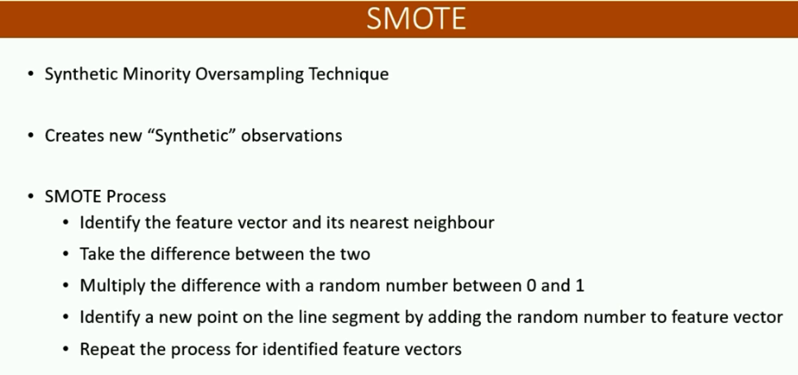

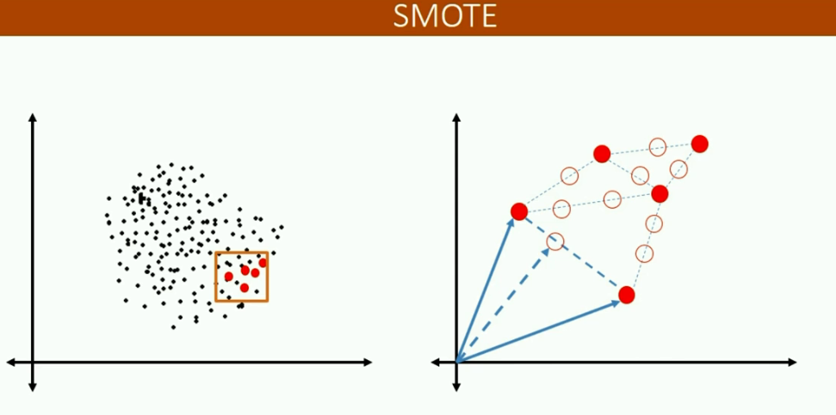

**Deploying R model as web service:**

Steps:

1. R version should be 3.4.1 or higher
2. Install rtools by following instructions from web
3. Install win zip
4. Make sure both rtools and winzip are added to environment variables path
5. Install packages ‘AzureML’, ‘devtools’

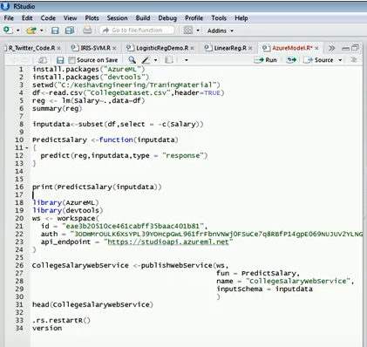

Games in R:

Package – fun

Function – gomoku(), mine_sweeper(), tower_of_hanoi(4)

Package = hangman

Function – hangman()

Package = gamer

Function – entangler()

**Fourier transformation:**

The Fourier Series only holds while the system is linear

Exercise: Get the monthly S&P 500 index (^GSPC) and plot the periodogram of the returns. Make sure that the number of returns is divisible by 12. Y <- read.csv("^GSPC.csv",na.strings="null") Y <- na.omit(Y) # rows with missing values are omitted N <- nrow(Y) # number of rows d <- as.Date(Y[,1]) # dates in column 1 y <- log(Y[,6]) # adjusted close prices in column 6 r <- y[2:N]-y[1:(N-1)] ; n <- N-1 # log returns n12 <- n-n%%12 # 29%%12=29 modulo 12=5 r12 <- r[(n-n12+1):n] # r12 contains the last n12 obs. m12 <- floor(n12/2); f12 <- (2*pi/n12)*(1:m12) ft12 <- fft(r12) # Fourier transform ft12 <- ft12[2:(m12+1)] # only frequencies 1,…,m pg12 <- (1/(2*pi*n12))*(Mod(ft12))^2 # periodogram par(mar=c(2,2,1,1)); plot(f12,pg12,type="l") n.years <- n12/12 # number of full years s <- n.years*(1:6) # indices of seasonal frequencies lines(f12[s],pg12[s],type="p",pch=20,col="red")

[**https://ocw.mit.edu/courses/mathematics/18-03sc-differential-equations-fall-2011/unit-iii-fourier-series-and-laplace-transform/fourier-series-basics/**](https://ocw.mit.edu/courses/mathematics/18-03sc-differential-equations-fall-2011/unit-iii-fourier-series-and-laplace-transform/fourier-series-basics/)

[**http://homepage.univie.ac.at/erhard.reschenhofer/pdf/zr/Spec.pdf**](http://homepage.univie.ac.at/erhard.reschenhofer/pdf/zr/Spec.pdf)

[**http://mesasoftware.com/papers/FourierTransformForTraders.pdf**](http://mesasoftware.com/papers/FourierTransformForTraders.pdf)

[**http://web.stanford.edu/~alahi/downloads/finance.pdf**](http://web.stanford.edu/~alahi/downloads/finance.pdf)

Here is what you can try:

* periodogram from TSA package, it immediately plots a periodogram.
* periodogram from GeneCycle, it returns a list of frequencies and estimated power spectral densities. It is a wrapper function for stats::spectrum with some special options set.
* spectrum from stats, it allows you to choose the method used to estimate the spectral density: either periodogram or using autoregressive process.
* cpgram from stats plots a cumulative periodogram together with a confidence interval.
* For the usage of fft see examples [here](http://homepage.univie.ac.at/erhard.reschenhofer/pdf/zr/Spec.pdf).

See ?cpgram and similar for all the details, and keep in mind that it is e.g. TSA::periodogram and GeneCycle::periodogram when names of the functions coincide.

As you probably know, the given time series must be detrended, so use e.g. diff(x) instead of x. And finally, the length of your time series must be divisible by 12 as to be able to identify 12 and 24 hours frequencies, it can be achieved by e.g. x[-(1:(length(x) %% 12))], where x is detrended

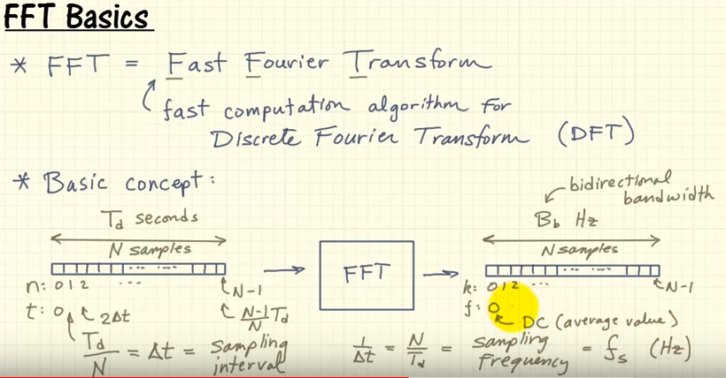

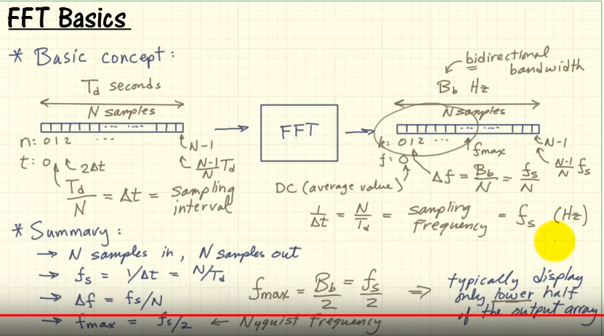

**Packages in R for fourier transform:**

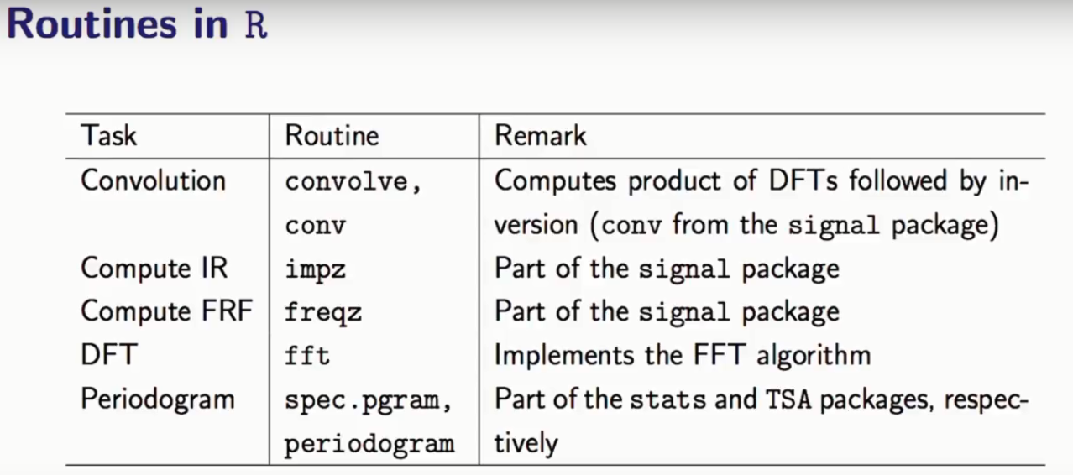

x[k] = cos(sqrt(2)k) -> discrete time signal -> this is not periodic because frequency is irrational.

Discrete time signal is periodic if and only if we are able to an interger numbr of observations after which repetition occurs. We cannot find such observation for this. On the other hand, this signal exists forever.

Whereas if we replace this with a continuous time signal, that will be periodic.

**Energy signal:**

Signal which can yield finite number of energy is called energy signal

Random signals are not energy signals because it is going to exist forever and there is noway integral is going to yield finite energy.

**Power signal:**

Signal with finite power is said to be power signal. Signal is said to be power signal if the power is non-zero and finite.

Power is rate at which energy changes over time.

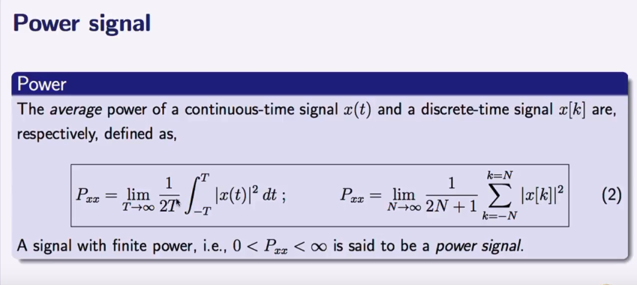

Any periodic signal which is not energy signal, but will be power signal. A signal cannot be both energy and power signal. If energy is finite, then average power over a finite time will be 0.

Is random signal a power signal?

Random signals are power signals because they will be stationary, means it cannot go unbounded and they have finite power.

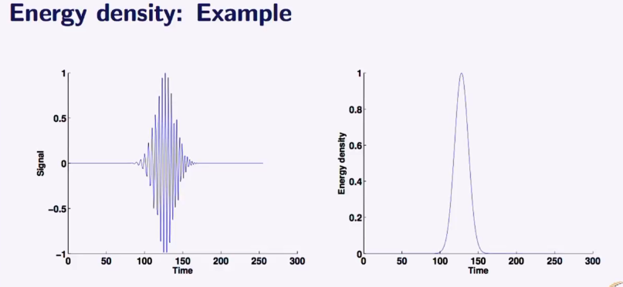Energy density is used in identifying fault identification, like how long the fault lasted and when it was started with respect to time.

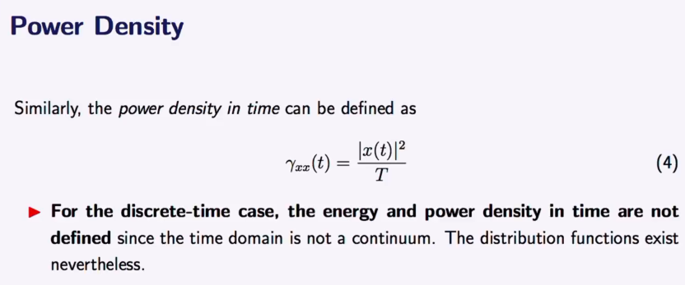

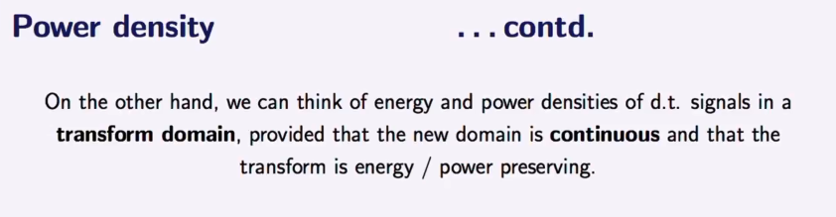

This transformed domain is frequency domain. So a discrete signal in time domain when transformed to frequency domain becomes continuous and density exists.

So, we are moving from densities in time to densities in frequency . This is possible through fourier transform.

Why we transform signals? Because it helps the analysis to view certain things clearly in transformed domain.

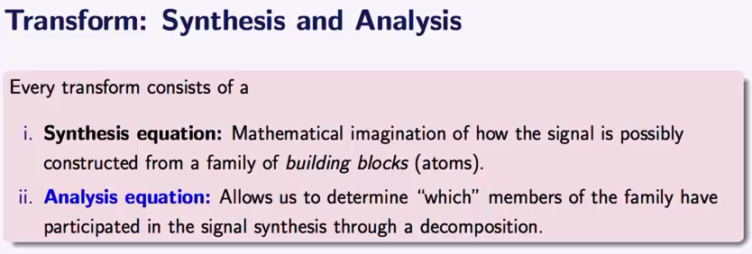

* A continuous-time signal is an infinite and uncountable set of numbers, as are the possible values each number can have. That is, between a start and end time, there are infinite possible values for time  and instantaneous amplitude, 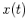.
* When continuous signals are brought into a computer, they must be digitized or discretized (i.e., made discrete).
* In a discrete-time signal, the number of elements in the set, as well as the possible values of each element, is finite, countable, and can be represented with computer bits, and stored on a digital storage medium.

All continuous-time signals are periodic but linear combination of multiple continuous periodic function, can be periodic or aperiodic.

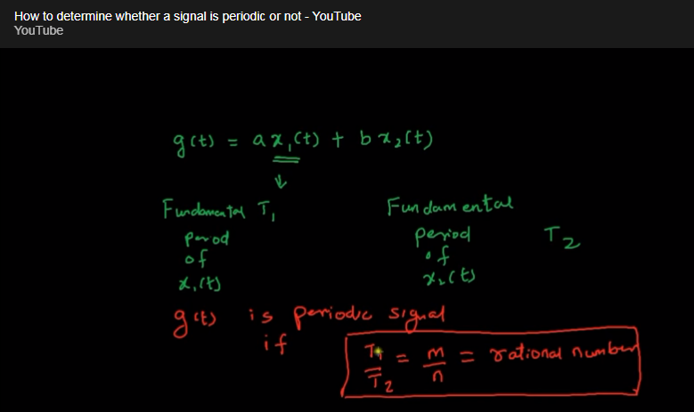

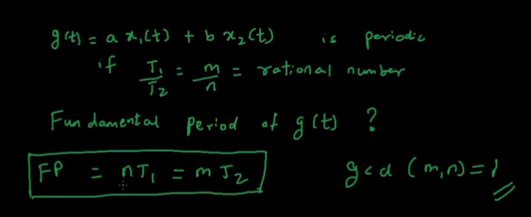

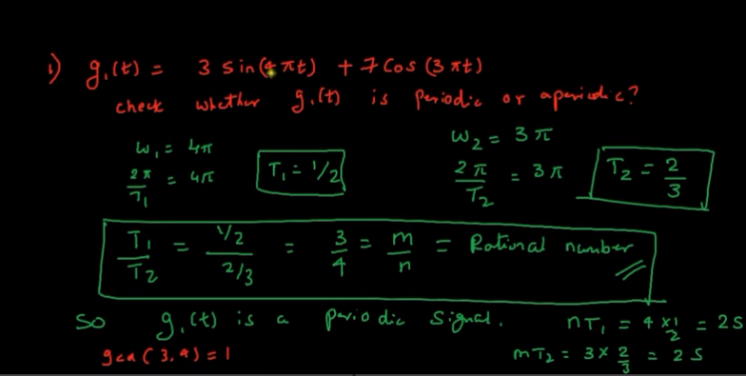

Fundamental period can be calculated for periodic signal, I wil be nT1 or mT2 (provided gcd (n,m) is 1) which is 2sec for g1(t)

Example 2:

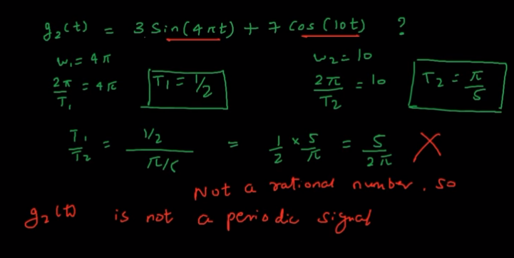

Though the individual signals are periodic, their linear combination is not. In below image, we could see the peak are starting at same place in left graph, hence it is periodic, whereas, in second, it is not starting at same place. Hence aperiodic.

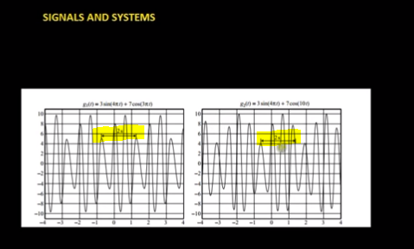

Why fourier transform

* Periodicity
* Filtering perspective
* Define spectral density so as to understand the linear random process is defined that way and so on.

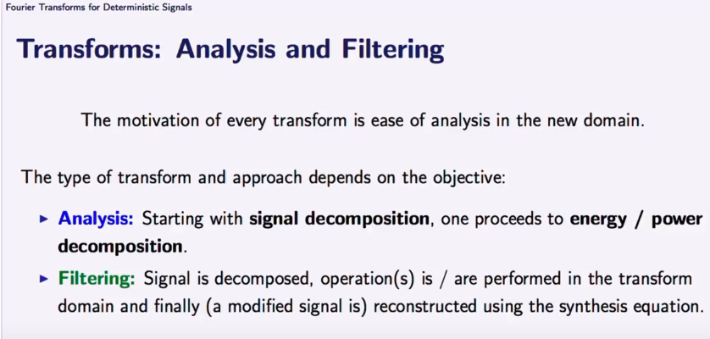

**Fixed vs Adaptive Basis:**

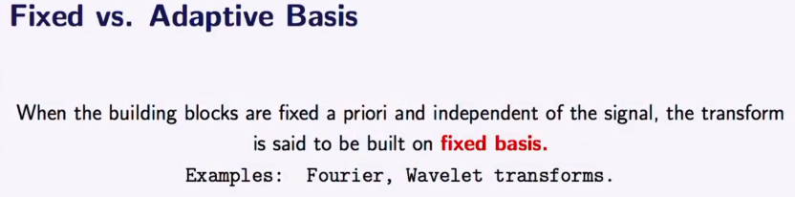

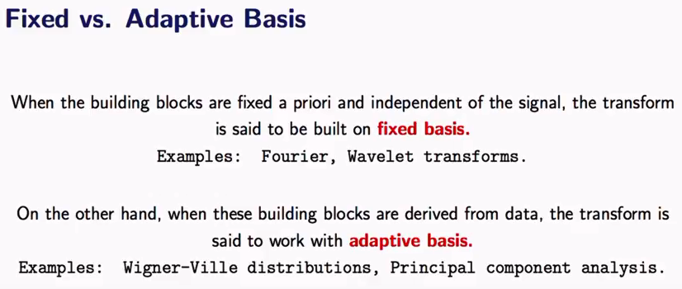

In fourier series, we assume that the series is made up of sine and cosine waves. This is the general assumption. So, the basis(or building block) of the series is assumed to be sine or cosine always. Hence it is fixed basis. In adaptive basis, there is no prior assumption.

In frequency domain plot(spectral plot or ), we plot the coefficients(|c(n)|^2) of each components of the signal against the n which is the number of harmonic. Coefficient is nothing but the contribution of nth harmonic to the overall power of the signal.

Fourier atoms must be orthogonal. IF each atom is unique in the family. In other words, what one atom or sine wave contributes to the overall power should be unique. No other sine wave or atom or building block should explain the same behavior of the signal. Only when the fourier atoms are orthogonal, we can say the coefficient of that atom is nothing but the contribution of nth harmonic to the overall power of the signal. (27B video in the series - <https://www.youtube.com/watch?v=G6OFvZoTblw&index=67&list=PLl0FT6O_WWDBm-4W-eoK34omYmEMseQDX>)

Then only we can say |c(n)|^2 is the unique contribution of nth harmonic to the power of the signal.

Since n is discrete in spectral plot, hence it is also called as line spectral plot. Iine spectral plot is symmetric with n, its ok to plot for non-negative n.. |c(n)| is complex number.. it has phase. Phase tells us where the signal should start..

Imagine a mason who wants to construct a wall with bricks(bricks here is sine and cosine waves) , so he has to use these bricks to construct the wall( assume a periodic wall) so he can only use these bricks. Coefficients tells us how much of these bricks he should have used to build that wall.

**Always, periodic signals don’t deal with densities. Only aperiodic signal deals with densities.**

**Aperiodic signal:**

Signal which never repeats after a certain period.

Or we can say aperiodic signal is a periodic signal with inifite period.

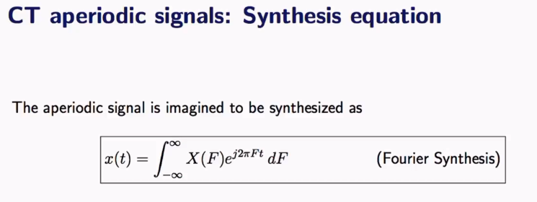

When we move from periodic to aperiodic, now signals are infinite period. So T(p) goes to inifinity.

In periodic case, there is frequency spacing which is called fundamental frequency. In aperiodic, since T(p) goes infinity, fundamental frequency is 0,

So, to express and aperiodic signal in terms of sine and cosine waves we need to consider all the frequencies as there is no fundamental frequencies.

C(n) is replaced with X(F) which is fourier transform. f is replaced with F.

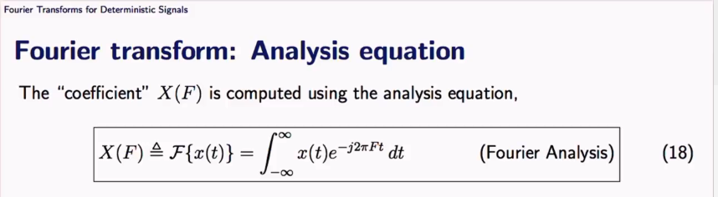

Why aperiod signal analysis is useful?

In periodic signal we analyse the outcome of the system. Ie. What output signal a particular signal generator has given.

In aperiodic, we analyze the system itself. Like what range of frequency it accepts and their behavior etc.

It’s matter of analyzing the system rather than the system’s output.

Periodic signals deal with power and aperiodic signals deals with energy.

Eg: If we want to analyze a speaker’s ability, we talk in terms of energy not power.

Here the system is speaker.

**Discrete Fourier transform – Periodic signal**

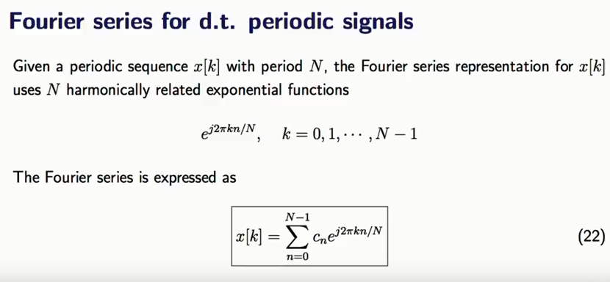

When we plot line spectrum in discrete case, we will go upto half of N-1 as the rest will be symmetry or repeats itself. This is the consequency of sampling in time causing the periodicity in frequency.

If it is odd, we can stop at exact half, if it is even, we can go one point more.

In periodic case, in both discrete and continuous signal, frequency axis is discrete. In aperiodic, in both discrete and continuous signal, frequency axis is continuous.

**Periodogram:**

Note that the periodogram of a sinusoidal tone will typically spike near the tone frequency and decay on either side (a phenomenon caused by the limited number of samples used for the estimation, often called [spectral leakage](https://en.wikipedia.org/wiki/Spectral_leakage)) until the value can be considered comparatively 'negligeable'.

**Interpreting the Periodogram :**

1. The periodogram is a very useful tool for describing a time series data set. We will see it is much more useful than the correlogram but it does require some training to interpret properly.

2. We will use the terms low frequency and high frequency extensively. The basic idea is that sinusoids of low frequency (or equivalently long period) are smooth in appearance whereas those of high frequency (or short period) are very wiggly. Thus if a time series appears to be very smooth (wiggly), then the values of the periodogram for low (high) frequencies will be large relative to its other values and we will say that the data set has an excess of low (high) frequency. For a purely random series, all of the sinusoids should be of equal importance and thus the periodogram will vary randomly around a constant.

3. If a time series has a strong sinusoidal signal for some frequency, then there will be a peak in the periodogram at that frequency.

4. If a time series has a strong nonsinusoidal signal for some frequency, then there will be a peak in the periodogram at that frequency but also peaks at some multiples of that frequency. The first frequency is called the fundamental frequency and the others called harmonics.

5. One of the aims of this course is to have you describe what a data set must look like when you can only see its periodogram

**Problems with Periodogram:**

1. Leakage
2. accuracy

**Leakage**

• occurs for non-periodic signals

• non-periodic signals violate FFT assumptions

• problem for real-world signals

• solution: windowing

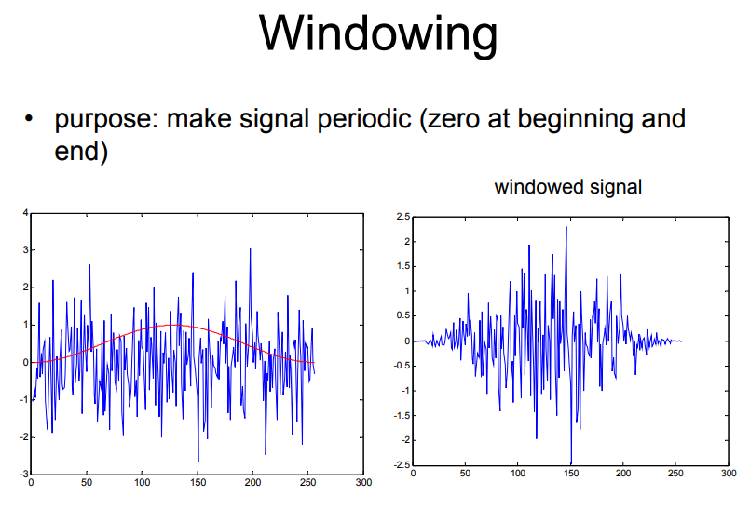

**Windowing (Good Link - https://in.tek.com/blog/window-functions-spectrum-analyzers)**

• windowing does not eliminate leakage but reduces it

• actually: it changes the shape of leakage

• wintool: to display and analyze windows

• standard window is Hanning window

• hw=hanning(256)

**Hamming window: (https://stackoverflow.com/questions/5418951/what-is-the-hamming-window-for)**

Imagine the signal you want to fourier transform is a pure sine wave. In the frequency domain, you would expect it to have a sharp spike only at the frequency of the sine. However if you took the fourier transform, your nice sharp spike would be replaced by something like this:

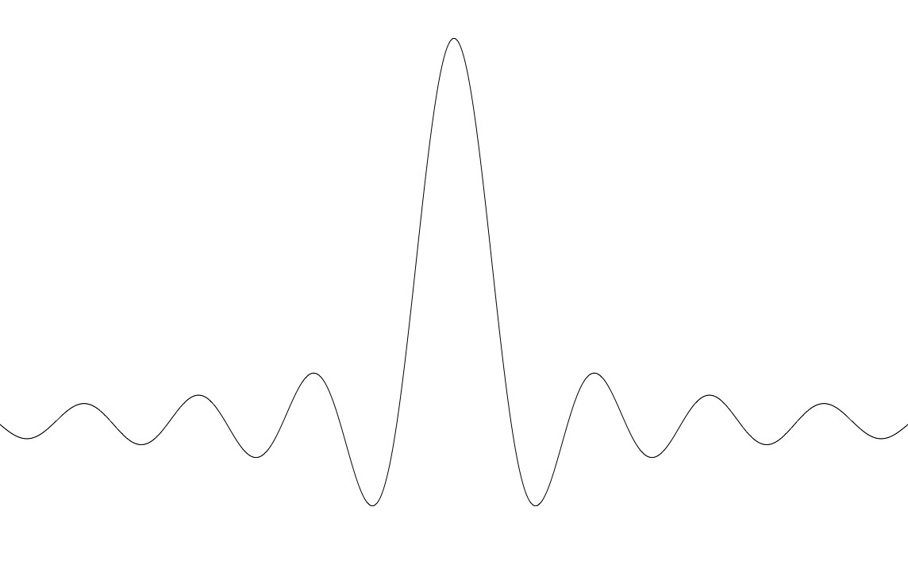

Why is that? Real sine waves extend to infinity in both directions. Computers can't do computations with an infinite number of data points, so all signals are "cut off" at either end. This causes the ripple on either side of the peak that you see. The hamming window reduces this ripple, giving you a more accurate idea of the original signal's frequency spectrum.

More theory, for the interested: when you cut your signal off at either end, you are implicitly multiplying your signal by a square window. The fourier transform of a square window is the image above, known as a sinc function. Whenever you do a fourier transform on a computer, like it or not, you're always choosing some window. The square window is the implicit default, but not a very good choice. There are a variety of windows that people have come up with, depending on certain characteristics you want to optimize. The hamming window is one of the standard ones.

**• Welchs Method:**

– divide time series in segments of equal length (typically 2^N samples)

– apply window

– compute fft

– average power spectra

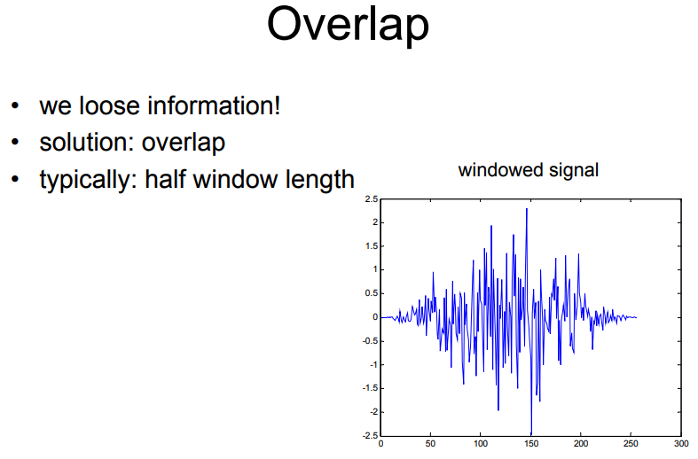

**Daniel filter:**

Smoothing the periodogram. The periodogram is a wildly fluctuating estimate of the spectrum with high variance. For a stable estimate, the periodogram must be smoothed.

Daniell filter differs from an evenly weighted moving average (rectangular filter) only in that the first and last weights are half as large as the other weights. A plot of the filter weights therefore has the form of a trapezoid. For example, the following figures shows filter weights of 5-weight Daniell and rectangular filters. The advantage of the Daniell filter over the rectangular filter for smoothing the periodogram is that the Daniell filter has less leakage, which refers to the influence of variance at non-Fourier frequencies on the spectrum at the Fourier frequencies.

**Modified Daniell**

There exist the modified Daniell kernel, which gives half of the weights of inner elements to the edge elements.

The test for periodicity can then proceed as follows:

Specify beforehand your period or frequency of interest 2. Estimate the spectrum and its 95% CI using the smoothed periodogram method 3. Estimate the null continuum using much greater smoothing of the periodogram 4. Plot the spectrum, its CI, and the null continuum, and consider a peak significant at 95% if its lower CI does not include the null continuum.

**Basic spectral analysis - Fourier transform :**

| **Quantity** | **Description** |
| --- | --- |
| x | Sampled data |
| n = length(x) | Number of samples |
| fs | Sample frequency (samples per unit time or space) |
| dt = 1/fs | Time or space increment per sample |
| t = (0:n-1)/fs | Time or space range for data |
| y = fft(x) | Discrete Fourier transform of data (DFT) |
| abs(y) | Amplitude of the DFT |
| (abs(y).^2)/n | Power of the DFT |
| fs/n | Frequency increment |
| f = (0:n-1)*(fs/n) | Frequency range |
| fs/2 | Nyquist frequency (midpoint of frequency range) |

**tbats() in r: (forecast package)**

The TBATS model is a time series model for series exhibiting multiple complex seasonalities.  Parallel processing is used by default to speed up the computations.

The TBATS model was introduced by [De Livera, Hyndman & Snyder (2011, *JASA*)](http://www.tandfonline.com/doi/abs/10.1198/jasa.2011.tm09771). "TBATS" is an acronym denoting its salient features:

* T for trigonometric regressors to model [multiple-seasonalities](https://stats.stackexchange.com/questions/tagged/multiple-seasonalities)
* B for [Box-Cox transformations](https://en.wikipedia.org/wiki/Power_transform)
* A for ARMA errors
* T for trend
* S for seasonality

The TBATS model is a generalization of the [BATS model](https://stats.stackexchange.com/tags/bats/info), which is similar except for lacking the trigonometric regressors.

The TBATS model can be fitted using the tbats() command in the forecast package for R.

gas <- read.csv("C:\\Users\\saranya_govindaraj\\Downloads\\Weekly_U.S._Product_Supplied_of_Finished_Motor_Gasoline.csv", skip = 4)

gas <- ts(gas[,1], start = 1991 +31/365.25, frequency = 365.25)

tsgas <- tbats(gas)

plot(tsgas)

fc2 <- forecast(tsgas, h=104)

plot(fc2, ylab ="thousands of barrels per day")

plot(gas)

**Keras:**

Setting up keras - <https://www.r-bloggers.com/a-newbies-install-of-keras-tensorflow-on-windows-10-with-r/>

**Tensorflow:**

<https://www.tensorflow.org/serving/>

<https://projector.tensorflow.org/>

**Ex-ante and Ex-post forecasts:**

**https://otexts.org/fpp2/forecasting-regression.html**

**Ex-ante forecasts** are those that are made using only the information that is available in advance. For example, ex-ante forecasts for the percentage change in US consumption for quarters following the end of the sample, should only use information that was available *up to and including* 2016 Q3. These are genuine forecasts, made in advance using whatever information is available at the time. Therefore in order to generate ex-ante forecasts, the model requires forecasts of the predictors. To obtain these we can use one of the simple methods introduced in Section [3.1](https://otexts.org/fpp2/simple-methods.html#simple-methods) or more sophisticated pure time series approaches that follow in Chapters [7](https://otexts.org/fpp2/expsmooth.html#expsmooth) and [8](https://otexts.org/fpp2/arima.html#arima). Alternatively, forecasts from some other source, such as a government agency, may be available and can be used.

**Ex-post forecasts** are those that are made using later information on the predictors. For example, ex-post forecasts of consumption may use the actual observations of the predictors, once these have been observed. These are not genuine forecasts, but are useful for studying the behaviour of forecasting models.

The model from which ex-post forecasts are produced should not be estimated using data from the forecast period. That is, ex-post forecasts can assume knowledge of the predictor variables (the xx variables), but should not assume knowledge of the data that are to be forecast (the yyvariable).

A comparative evaluation of ex-ante forecasts and ex-post forecasts can help to separate out the sources of forecast uncertainty. This will show whether forecast errors have arisen due to poor forecasts of the predictor or due to a poor forecasting model.

**Implementation of R model/ Productionizing R model:**

1. Data is fetched from RDBMS database (Oracle) and pushed to MongoDB
2. To complete the data insertion process Kafka is used
3. Set of rules and compliances is created in Kafka which takes care of data integrity and smooth insertion of data in MongoDB
4. From MongoDB connection drivers are used to get the data in RStudio server and in python environment.
5. In R data is stored in different data frames to be used for analytical process.
6. New dat points aer passed through model and set of rules to get the final output.
7. Final output is stored in csv file format.
8. DMaap is used to write these output files to the external data source which is again RDBMS.
9. All the tools and MongoDB have been installed on Linux server.
10. Kubernet is used provide analytical interface and platformto make connections with different components.

**Variable selection:**

<https://www.youtube.com/watch?v=zRhqUMoiMEQ&list=PLzOz0tl6F3-BEcoYz3C8K5_NrOqpryzYv&index=13>

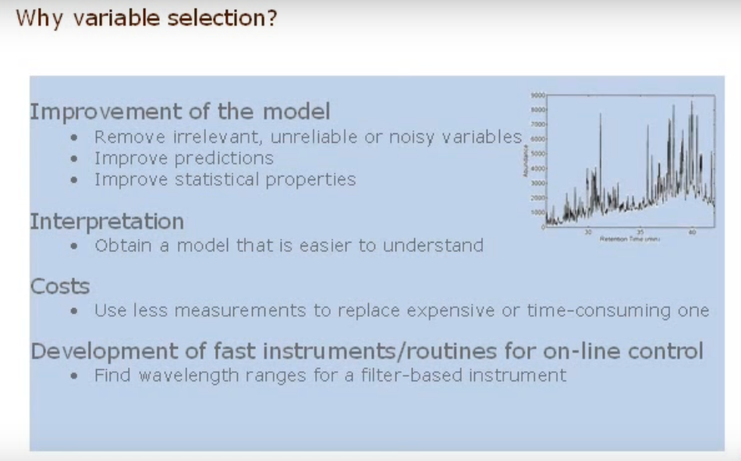

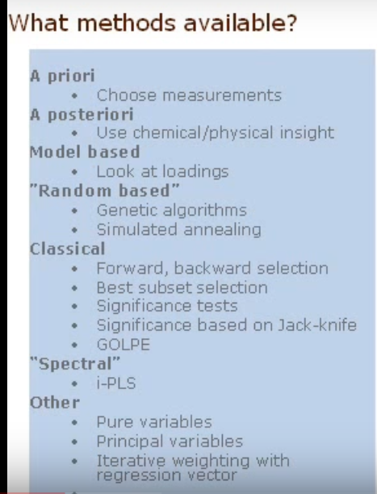

**Transfer learning:**

<https://towardsdatascience.com/transfer-learning-leveraging-insights-from-large-data-sets-d5435071ec5a>

**Factor anlaysis:**

<https://visualstudiomagazine.com/articles/2017/03/01/revealing-secrets-r-factor-statistics.aspx>

**Pytorch tutorial:**

<https://www.kaggle.com/ashishpatel26/zero-to-hero-in-pytorch-ml-dl-rl>

**Tips & Tricks:**

1. Devtools::ingh => if you type it will auto complete to devtools::install_github()
2. Make code snippets and save in tools-> global options -> code -> edit snippets

And then type the snippet name and press Shift+tab -> this will auto complete the snippet code.

1. Use history tab to rerun the same commands either in console or in source window. There are 2 buttons at top to redirect the history commands to console or to source file.
2. Navigation -> if we want to go to any files, functions or objects, we can do that quickly by typing in the Go to bar in tool bar. Short cut is (Ctrl + .) This search happens within Rstudio
3. If we want to search through out the computer, then type (Ctrl+Shift+f) which will look for value and returns.
4. Navigation -> auto complete file paths within double quotes+tab.
5. To close tabs that are open, Go to file -> close or File -> close all or File -> close all except current. or use (ctrl+shift+.) where you can select the tab which you want to close.
6. To view all keyboard shortcuts in R studio type (Alt+shift+k). you can modify the keyboard shortcuts or create new using Tools -> Modify keyboard shortcuts.

**Docstring:**

In [programming](https://en.wikipedia.org/wiki/Computer_programming), a docstring is a [string literal](https://en.wikipedia.org/wiki/String_literal) specified in [source code](https://en.wikipedia.org/wiki/Source_code) that is used, like a [comment](https://en.wikipedia.org/wiki/Comment_(computer_programming)), to document a specific segment of code.

> library(docstring)

>

> my_func <- function(a,b){

+ #' This is add function

+ #'

+ #' This adds the 2 inputs passed

+ #' @param a first input

+ #' @param b second input

+ #'

+ #' @examples

+ #' my_func(1,2)

+ #' my_func(100,4)

+ #'

+ #' @details This returns sum of any 2 numbers

+ return(a+b)

+ }

>

> my_func(1,3)

[1] 4

> docstring(my_func)

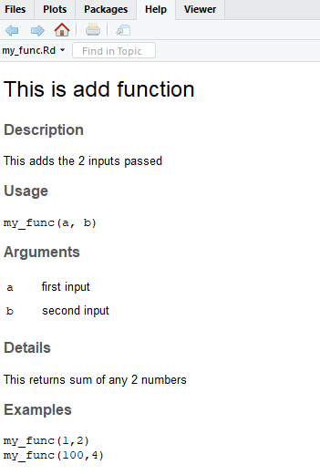

**Github installation techniques**

<https://cran.r-project.org/web/packages/githubinstall/vignettes/githubinstall.html>

Anomaly detection techniques:

<http://around-r.blogspot.com/2016/10/anomaly-detection-in-time-series-data.html>

anomaly detection – multivariate timeseries:

<https://github.com/khundman/telemanom/blob/master/results/result-viewer.ipynb>

Anomaly Detection using H2o

https://rpubs.com/mr148/316143

croston: - How it works

<https://pdfs.semanticscholar.org/9299/a1408190cd9f1b4653e72f4a7a8b7716d984.pdf>

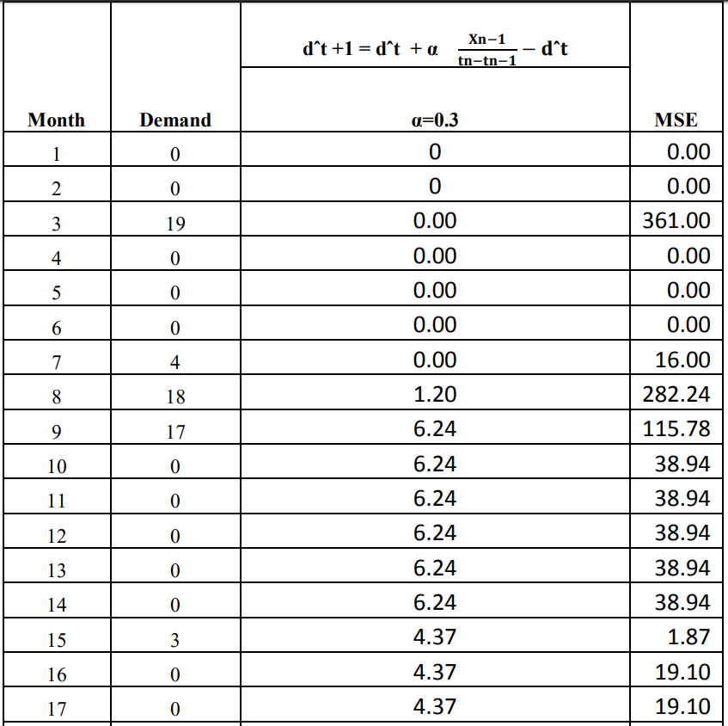

> 0+0.3*(4/1-0)

[1] 1.2

> 1.20+0.3*(18-1.2)

[1] 6.24

> 1.20+0.3*(18-1.2)

[1] 6.24

**Loess curve fitting (local polynomial regression) -** <https://www.youtube.com/watch?v=Vf7oJ6z2LCc>

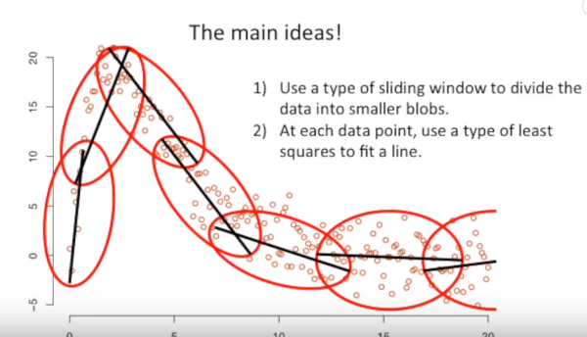

Using weighted least square on sliding window new points are arrived.

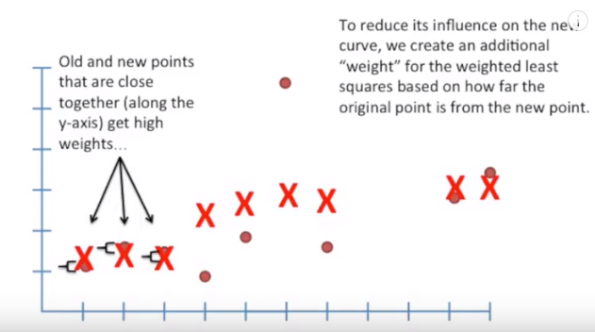

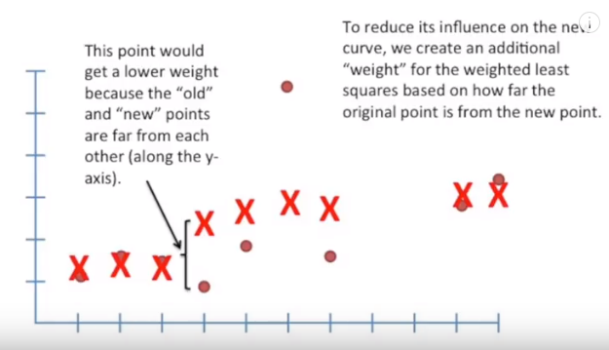

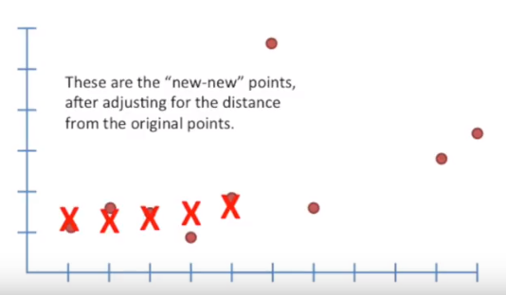

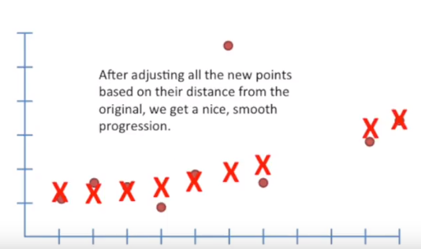

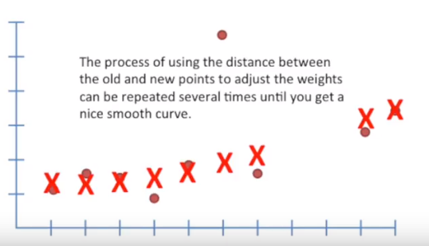

We can fit either line or parabolas to the data points.

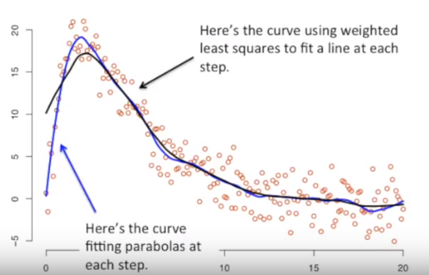

**R code in Microsoft SQL server:**

<https://www.blue-granite.com/tutorials/sql-server-r-services>

**R code in Python:**

<https://community.alteryx.com/t5/Data-Science-Blog/RPy2-Combining-the-Power-of-R-Python-for-Data-Science/ba-p/138432>

**difference between saverds and save:**

<https://www.fromthebottomoftheheap.net/2012/04/01/saving-and-loading-r-objects/>